Reception | Autumn 1 – Knowing Yourself |  |  |  |  | Autumn 2 - Into the Woods
Writing Root Text | 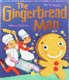  Traditional Tales instead of whole school unit  The Gingerbread Man | 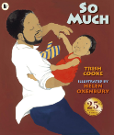  So Much!  Trish Cooke |  | 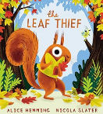  The Leaf Thief  Alice Hemming |  | 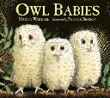  Owl Babies  Maritn Waddell |  | 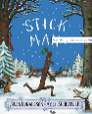  Stick Man  Julia Donaldson
Theme/Term | Spring 1 – Talents and Powers |  |  |  |  | Spring 2 – Sowing a Seed
Writing Root Text | 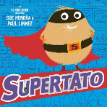  Supertato  Sue Hendra and Paul Linnett |  | 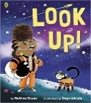  Look Up!  Nathan Bryon |  |  | 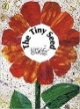  The Tiny Seed  Eric Carle |  | 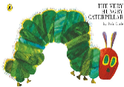  The Very Hungry Caterpillar  Eric Carle
Theme/Term | Summer 1 - Animals |  |  |  |  | Summer 2 - Journeys
Writing Root Text | 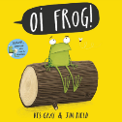  Oi Frog!  Kes Gray |  | 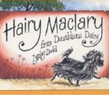  Hairy Maclary from Donaldson’s Dairy  Lynley Dodd |  |  | 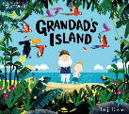  Grandad’s Island  Benji Davies |  | 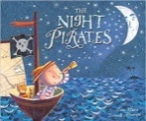  Night Pirates  Peter Harris
Year 1 | Autumn 1 – Who am I going to be? |  |  |  |  | Autumn 2 – I am an Explorer
Writing Root/  Spelling Seed Text | 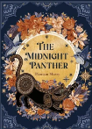  The Midnight Panther  Poonam Mistry |  | 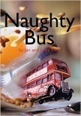  Naughty Bus  Jan and Jerry Oke  Adventure Story |  |  | Iggy Peck, Architect  Andrea Beaty and David Roberts  Fact File  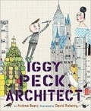 |  | 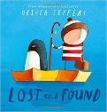  Lost and Found  Oliver Jeffers  ‘Losing and Finding’ narrative
Theme/Term | Spring 1 – It’s good to be ME! |  |  |  |  | Spring 2 – I can overcome challenges
Writing Root/  Spelling Seed Text | 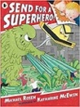  Send for a Superhero  Michael Rosen & Katharine McEwan  Superhero Narrative |  | 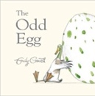  The Odd Egg  Emily Gravett  Egg Spotter Guide |  |  | 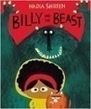  Billy and the Beast  Nadia Shireen  ‘Defeat a monster’ narrative |  | 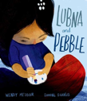  Lubna and Pebble  Wendy Meddour  ‘Gifting’ narrative
Theme/Term | Summer 1 – Animals and Me! |  |  |  |  | Summer 2 – Pride and Loss
Writing Root/  Spelling Seed Text | 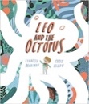  Leo and the Octopus  Isabelle Marinov  Fact File |  | 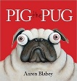  Pig the Pug  Aaron Blabley  How two guide |  |  | 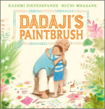  Dadaji’s Paintbrush  Rashmi Sirdeshpande  Narrative |  | 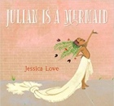  Julian is a Mermaid  Jessica Love  Three-Verse Poem
Year 2 | Autumn 1 - Fire, Fire! |  |  |  |  | Autumn 2 – People and Places
Writing Root/  Spelling Seed Text | The Midnight Panther  Poonam Mistry |  |  |  | 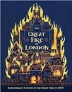  The Great Fire of London  Emma Adams  Information Booklet |  | A Walk in London  Salvatore Rubbino  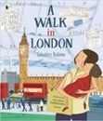  ‘A walk in…’ tour guide
Literary Leaf Text | Time to be given to phonics revision to support fluency. Do you want a text here? |  |  |  |  | 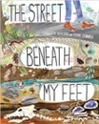  The Street Beneath my Feet  Charlotte Guillian
Theme/Term | Spring 1 – Ribbit, Ribbit! |  |  |  |  | Spring 2 – What a Wonderful World!
Writing Root/  Spelling Seed Text | 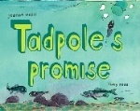  Tadpole’s Promise  Jeanne Willis  Own Version Narrative |  |  |  | 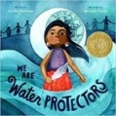  We are Water Protectors  Caroline Lindstrom  Non-Chronological Report |  | 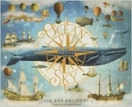  Ocean Meets Sky  The Fan Brothers  Fantasy Narrative
Literary Leaf Text | 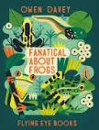  Fanatical about Frogs  Owen Davey |  |  |  |  | 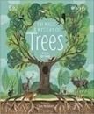  The Magic and Mystery of Trees  Jen Green
Theme/Term | Summer 1 – Traditional Tales with a Twist |  |  |  |  | Summer 2 – Are Bears Always Grizzly?
Writing Root/  Spelling Seed Text | 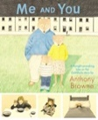  The Goldilocks Project  Anthony Browne, Lauren Child and Leiugh Hodgkinson  Sequel Story |  |  |  |  | 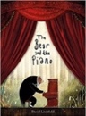  The Bear and the Piano  David Litchfield  Narrative with the theme of bravery
Literary Leaf Text | 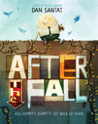  After the Fall  Dan Santat |  |  |  |  | 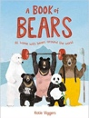  A Book of Bears  Katie Viggers
Year 3 | Autumn 1 - Curiosity |  |  |  |  | Autumn 2 – A Stone Age Adventure
Writing Root/  Spelling Seed Text | The Midnight Panther  Poonam Mistry |  |  |  | 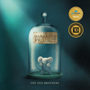  The Barnabus Project  The Fan Brothers  Brochure |  | 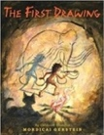  The First Drawing  Mordicai Gerstein  Historical Narrative
Literary Leaf Text | 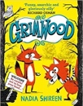  Grimwood  Nadia Shireen |  |  |  |  | 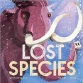  Lost Species  Jess French
Theme/Term | Spring 1 – Conservation Warriors |  |  |  |  | Spring 2 – A Journey Down the Nile
Writing Root/  Spelling Seed Text | The Tin Forest  Helen Ward  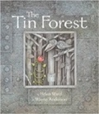  Persuasive Information Leaflet |  |  |  | 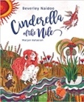  Cinderella of the Nile  Beverley Naidoo  Own Version Narrative |  | 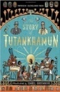  The Story of Tutankhamun  Patricia Cleveland-Peck  Biography
Literary Leaf Text | 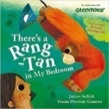  There’s a Rang-Tan in my Bedroom  James Sellick |  |  |  |  | 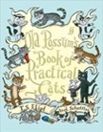  Old Possum’s Book of Practical Cats  T. S. Eliot
Theme/Term | Summer 1 – Magic and Wonder |  |  |  |  | Summer 2 – Adventure Time!
Writing Root/  Spelling Seed Text | 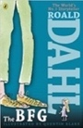  The BFG  Roald Dahl  Fantasy Narrative |  |  |  |  | 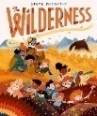  The Wilderness  Steve McCarthy  Guide to enjoying the Wilderness
Literary Leaf Text | 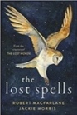  The Lost Spells  Robert MacFarlane |  |  |  |  | 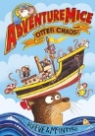  AdventureMice: Otter Chaos  Philip Reeve & Sarah McIntyre
Year 4 | Autumn 1 – If You Can Dream It… |  |  |  |  | Autumn 2 – Journeys
Writing Root/  Spelling Seed Text | The Midnight Panther  Poonam Mistry |  |  |  | Tar Beach  Faith Ringgold  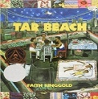  Narrative Retelling as a Playscript |  |   Shackleton’s Journey  William Grill  Newspaper Report/ Blog
Literary Leaf Text | 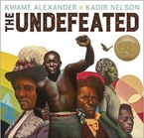  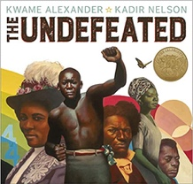  The Undefeated  Kwame Alexander |  |  |  |  | 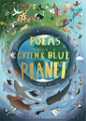  Poems from a Green and Blue Planet  Sabrina Mahfouz
Theme/Term | Spring 1 - Groundbreaking… Nonsense! |  |  |  |  | Spring 2 – Save the Planet! It’s up to us!
Writing Root/  Spelling Seed Text | 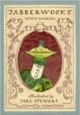  Jabberwocky  Lewis Carroll  Nonsense Poem |  |  |  | 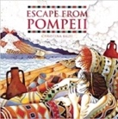  Escape from Pompeii  Christina Balit  Newspaper Report |  | 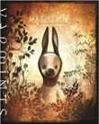  Varmints  Helen Ward  Explanation Text
Literary Leaf Text | 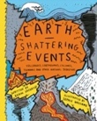  Earth Shattering Events  Robin Jacobs |  |  |  |  | 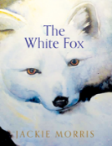  The White Fox  Jackie Morris
Theme/Term | Summer 1 – Pride and Loss |  |  |  |  | Summer 2 – Myths and Legends
Writing Root/  Spelling Seed Text | 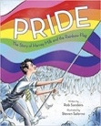  Pride: The Story of Harvey Milk and the Rainbow Flag  Rob Sanders  Biography |  |  |  |  | 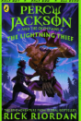  Percy Jackson and the Lightning Thief  Rick Riordan  Mythical Narrative
Literary Leaf Text | 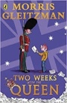  Two Weeks with the Queen  Morris Gleitzman |  |  |  |  | 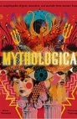  Mythologica  Dr. Stephen P. Kershaw

Year 5 | Autumn 1 - Legend has it… |  | Autumn 2 – Oh, Brave New World!
Writing Root/  Spelling Seed Text | The Midnight Panther  Poonam Mistry | 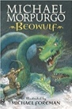  Beowulf  Michael Morpurgo  Own Version Legend |  | The Tempest  William Shakespeare  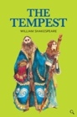  Playscript
Literary Leaf Text | 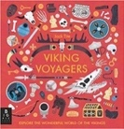  Viking Voyagers  Jack Tite |  | 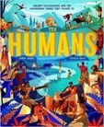  The Humans: Ancient civilisations  Jonny Marx
Theme/Term | Spring 1 – What’s Your Superpower? |  | Spring 2 – Drama and Danger!
Writing Root/  Spelling Seed Text | 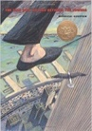  The Man Who Walked Between the Towers  Mordicai Gerstein  Biography | 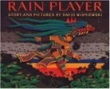  Rain Player  David Wisniewski  Analytical Essay |  | 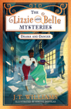  The Lizzie and Belle Mysteries  J.T. Williams  Persuasive Speech
Literary Leaf Text | 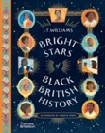  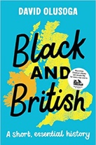  Bright Stars of Black British History  J.T Williams |  | 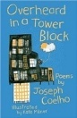  Overheard in a Tower Block  Joseph Coelho
Theme/Term | Summer 1 – Titanic Voyage |  | Summer 2 – It’s a Mystery!
Writing Root/  Spelling Seed Text | 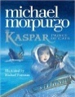  Kaspar, Prince of Cats  Michael Morpurgo  Newspaper Article |  | 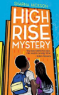  High Rise Mystery  Sharna Jackson  Extended Narrative
Literary Leaf Text | 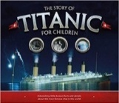  The Story of Titanic for Children  Joe Fullman |  | 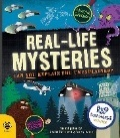  Real life mysteries  Susan Martineau
Year 6 | Autumn 1 – Lessons from the Past |  | Autumn 2 – We’ll Meet Again
Writing Root/  Spelling Seed Text | The Midnight Panther  Poonam Mistry | 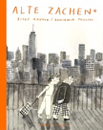  Alte Zachen  Ziggy Hanaor  Analytical Essay |  | 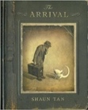  The Arrival  Shaun Tan  Own version narrative
Literary Leaf Text | 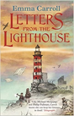  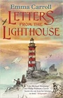  Letters from the Lighthouse  Emma Carroll | 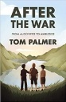  After the War: From Auschwitz to Ambleside  Tom Palmer |  | 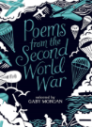  Poems from the Second World War  Gaby Morgan
Theme/Term | Spring 1- A Voyage of Discovery |  | Spring 2 – Battle for Equality
Writing Root/  Spelling Seed Text | 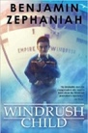  Windrush Child  Benjamin Zephaniah  Persuasive Pitch |  | 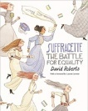  Suffragette: The Battle for Equality  David Roberts  Campaign/ Short news report
Literary Leaf Text | 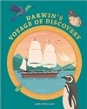  Darwin’s Voyage of Discovery  Jake Williams |  | 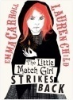  The Little Match Girl Strikes Back  Emma Carroll
Theme/Term | Summer 1 – Fate or Free Will? |  | Summer 2 – Parting is Such Sweet Sorrow
Writing Root/  Spelling Seed Text | 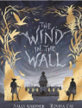  The Wind in the Wall  Sally Gardner  Extended Gothic Narrative |  | 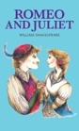  Romeo and Juliet  William Shakespeare  Playscript
Literary Leaf Text | 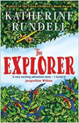  The Explorer  Katherine Rundell |  | 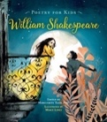  Poetry for Kids: William Shakespeare illustrated edition  William Shakespeare

