Oakdene Primary School



Child Protection and Safeguarding Policy

Approved by Full Governing Body on ______________________
To be reviewed on or before _September 2025____________________________

Signed __________________________ Chair of Governors
Signed _________________________________ Headteacher

Contents:
1. | Rationale and Purpose
2. | Roles and responsibilities
3. | Types and definitions of abuse
4. | Prevention and Early Help
5. | Child Protection Procedures
6. | Further Safeguarding Arrangements
7. | Links to other policies

- Rationale and Purpose
Oakdene Primary School recognises its obligation under Section 175 of the Education Act 2002 and the Children’s Act 1989 and 2004, to promote and safeguard the welfare of all its pupils and sees its Child Protection and Safeguarding Policy as fulfilling a key part of this duty.
The purpose of this policy is to ensure that there is clear guidance and robust procedures around safeguarding and child protection, for all governors, staff (including volunteers), parents, carers, visitors and most importantly, for our pupils and their siblings and/or wider family. Oakdene Primary School believes that all children, regardless of ethnicity, nationality, religion, culture, gender, family circumstances and ability, have the right to be protected from abuse. Oakdene Primary School also believes that all children also have the right to have a safe and nurturing childhood so they are placed in the best possible position to meet all of their health, social, emotional and educational outcomes.
This purpose and rational directly runs alongside our mission statement ‘Growing and Learning Together’.
Here at Oakdene Primary School, we believe that our core values of determination, honesty, respect, responsibility, pride and friendship are fundamental in regards to our safeguarding and child protection procedures.
Here at Oakdene Primary School, we fundamentally believe that every child has the right to be happy, healthy and safe. Therefore, we must ensure that out safeguarding practices are thoroughly effective and appropriately developed to meet the individual needs of our children.
Definition
Safeguarding and promoting the welfare of children is defined as, in accordance with Keeping Children Safe in Education 2024 “protecting children from maltreatment, preventing impairment of children’s mental and physical health or development; ensuring that children grow up in circumstances consistent with the provision of safe and effective care; and taking action to enable all children to have the best outcomes. Children includes everyone under the age of 18. (p.7 Keeping Children Safe in Education 2024).
Introduction
Oakdene Primary School fully recognises the responsibility it has to effectively safeguard children. We believe that we have a significant contribution to make in ensuring all children are kept safe and achieve the outcomes they deserve.
There are three main elements to our Child Protection and Safeguarding Policy:
- Procedures for identifying and reporting cases or suspected cases of abuse and key named members of staff with specific safeguarding responsibilities. Due to our day to day contact with children, we strongly believe school staff are well placed to identify and act upon signs and indications of abuse.
- Support for pupils who may have been subject to abuse and working with families and additional agencies in order to address any safeguarding issues and achieve positive outcomes.
- Prevention through building the self-esteem and resilience of pupils and authentic and valued relationships with children and families.
This policy applies to all staff and volunteers working in Oakdene Primary School, community education staff, temporary, part-time and supply staff and governors. All adults who come into school, for whatever reason, have a statutory duty to safeguard all of our children. Teaching assistants, mid-day assistants, office and cleaning staff as well as teachers can be the first point of disclosure for a child and therefore it is essential that all adults present in school are able to deal with child protection concerns quickly, confidently and effectively. Concerned parents, carers or members of the community may also contact the school if they are concerned about the welfare of a child of family.
This policy is written in line with Section 175 of the Education Act 2002 and the Children’s Act 1989 and 2004. The policy is also compliant with key statutory guidance including ‘Working Together to Safeguard Children’ (2018) and ‘Keeping Children Safe in Education’ (2024). This policy also runs alongside the government guidance ‘What to do if you are worried a child is being abused – Advice for practitioners’ (2015) and ‘Statutory framework for the early years and foundation stage’ (2023). Our Child Protection and Safeguarding Policy also reflects and is in line with the policies and practices of the St. Helens Safeguarding Children Partnership and Pan-Merseyside Safeguarding Procedures.
All staff at Oakdene Primary School have a responsibility to read and adhere to the Child Protection and Safeguarding Policy along with other relevant supporting documents. These include ‘Keeping Children Safe in Education (2024)’ (full document for the DSL, Deputy DSL, Senior Leaders and Governors and Part 1 and Annex A for all other staff); Working Together to Safeguard Children’ (2018); ‘What to do if you are worried a child is being abused – Advice for practitioners’ (2015); and the staff code of conduct.
All staff and governors must sign to state that they have read and understood any guidance or legislation they are required to read.
Safeguarding is a shared responsibility and therefore all adults have a part to play in keeping our children and young people safe. This includes members of school staff working with families and additional external agencies in order to achieve the best outcomes for our children. Oakdene Primary School recognises that collaborative working and sharing information is essential in order to effectively safeguard our children.

Please note that if you are ever concerned about the welfare of a child or family you must call The Contact Centre on 01744 676767 or, if it is after 5pm, The Emergency Duty Team (EDT) on 0345 050 0148.
Please contact the Police on 999 if you feel that a child or young person is in immediate danger.

- Roles and Responsibilities
Designated Safeguarding Lead
The Children’s Act (2004) states that every organisation must have a “named person” for safeguarding. Keeping Children Safe in Education (2024), states that the Designated Safeguarding Lead (DSL) must be an ‘appropriate senior member of staff, from the school or college leadership team’ (p.28). Here at Oakdene Primary School we have a named DSL and named Deputy DSLs. Both the DSL and the Deputy DSLs are members of the Senior Leadership Team and have a variety of roles and responsibilities related to safeguarding which are listed below.
The Designated Safeguarding Lead is:
Martin Weston – Deputy Headteacher
Telephone – 01744 678410
Email – martin.weston@sthelens.org.uk
The Deputy Designated Safeguarding Leads are:
Lynsey Young – Headteacher Caroline Hughes – Assistant Headteacher
Telephone – 01744 678410 Telephone – 01744 678410
Email – lynsey.young@sthelens.org.uk Email – caroline.hughes@sthelens.org.uk
Andrea Green – Pastoral Lead
Telephone – 01744 678410
Email – andrea.green@sthelens.org.uk
Roles and responsibilities of the Designated Safeguarding Lead:
- The DSL has lead responsibility for dealing with any safeguarding and child protection concerns in school. It is important that someone is available at all times to deal with any concerns or offer support or guidance to staff. This means that Oakdene Primary School has implemented safeguarding systems that are robust and allow an alternative appropriate member of staff (such as the Deputy DSLs ) to deal with a child protection concern quickly and effectively in the DSL’s absence.
- It is always best practice to have the DSL or Deputy DSL on site. However, it may be unavoidable that the DSL will not be present in school due to their work pattern (such as attending training or meetings for example). In such circumstances, the DSL needs to be contactable at all times should a safeguarding issue arise. Should the DSL not be in school the Deputy DSL should be contacted in their absence. All staff will be notified if the DSL or Deputy DSL(s) are not on site.
- The DSL acts as a source of support, guidance and expertise when deciding how to deal with a child protection concern. This can include making a referral to an external agency, including Children’s Social Care.
- The DSL receives dedicated Designated Safeguarding Lead training, which qualifies them to take on this role in school. This needs to be updated a minimum of every two years however Oakdene Primary School recognises and ensures that the DSL should receive regular updates, briefings and training on a wide array of safeguarding topics to ensure their knowledge is comprehensive and up to date. This broad range of training ensures that the DSL is confidently able to deal with a vast array of issues at a professional level.
- The DSL will provide statutory Safeguarding Training to all staff and long-term volunteers or students on an annual basis. For short term volunteers and members of staff, such as supply teachers, a Safeguarding Induction will be completed which will adequately equip them on how to effectively deal with safeguarding concerns in school.
- The DSL, along with all staff, will be able to recognise signs and symptoms of abuse. However, it will be the DSL’s responsibility to make an appropriate judgement on what action to take. This will be based on the concern raised in accordance with the Local Authorities Descriptions of Need.
- The DSL will make the decision of when to offer families support and at what level. This includes any Early Help or intervention or referrals to external agencies such as Children’s Social Care.
- The DSL will attend regular training and network events and keep up to date with statutory guidance, changes in legislation and develop their knowledge around new and prevalent safeguarding topics.
- The DSL is responsible for writing and reviewing the school’s Child Protection and Safeguarding Policy and ensuring it contains relevant and up to date information. All staff and parents/carers of children who attend Oakdene Primary School have a responsibility to read and adhere to the school’s Child Protection and Safeguarding Policy.
- The DSL is responsible for creating and maintaining written or online records of child protection and safeguarding concerns. Some individual children will have an individual safeguarding file which provides a chronology for professionals. This includes, for example, any concerns that have been raised, meeting minutes or multi-agency referrals. Here at Oakdene Primary School, we use a secure web-based system called CPOMS to record any safeguarding or Child Protection issues. Oakdene Primary School adheres to GDPR data protection rules and regulations; this means that individual safeguarding files will be archived as part of the CPOMS system. Please note, the school will share information with other professionals if this is deemed to be necessary and in the best interest of the child’s safety. This includes requests for information from other services such as the police or Children’s Social Care. All individual safeguarding files should create an accurate and factual picture of a child and should be a proactive tool in preventing any safeguarding concerns from escalating.
- The DSL will either complete or contribute to the S175Audit which is reviewed and quality assured by the St. Helens Safeguarding Children’s Partnership. This is a self-assessment tool which is used to ensure that school’s safeguarding procedures are robust and effective.
- The DSL is aware of the St. Helens Safeguarding Children Partnership (SHSCP) and how it operates. The DSL will also attend regular training provided by SHSCP.
- The DSL will attend multi-agency meetings and provide concise and accurate written reports stating and concerns or significant events, the strengths of the children and family and the school’s perspective and professional opinion on the situation. The DSL will work with class teachers and other relevant members of staff in order to comprise an accurate and factual report. The DSL will also obtain the wishes and feelings of the child or young person, so their views are incorporated and shape the report. The DSL will attend Child Protection Conferences and will be responsible for contributing to the decision as to whether a child should be subject to a child protection plan.
- The DSL will provide written reports and contributions to external agency assessments. This can include Child and Family Assessments (social care), CAMHS assessments and Family Action Meetings (this is not an exhaustive list). Again, if sharing information is deemed to be necessary in order to ensure the safety or protection of a child, then the DSL will provide a report to the relevant agency. Parents or carers consent will be sought in most cases however there may be occasions where this is not appropriate or may compromise the safety of the child. It is school’s ethos, to work with our families openly and transparently. We recognise and strongly believe that this way of working strengthens relationships and improves outcomes for our children. We also strongly appreciate the vital role that parents, and carers have in the lives of their children and that this is fundamental to successful safeguarding practice.
- The DSL will create and maintain the school’s Vulnerability Risk Register, kept in the school electronic Safeguarding folder. This is a fluid, working document which lists all the school’s vulnerable children. This document allows the DSL and senior staff to be aware of and vigilant to individual vulnerabilities so that we can be proactive and offer families the best support possible at the earliest opportunity.
- The DSL monitors attendance and checks on the welfare of children who are not in school. The Child Protection and Safeguarding Policy is directly linked to and supports the school’s attendance policy.
- The DSL with work with the Designated Teacher for Looked After Children and the Virtual School and Virtual Headteacher, to support the outcomes and achievements of Looked After pupils, as well as those who may have a social worker.
Roles and responsibilities of the Deputy Safeguarding Lead:
- The Deputy DSL is responsible for dealing with any child protection concerns in the absence of the DSL.
- The Deputy DSL is a strategic part in the development and implementation of the school’s safeguarding policies and procedures.
- The Deputy DSL also receives additional training, including the Level 3 training which qualifies them as the Designated Safeguarding Lead.
Representation at meetings during school holidays
Due to the term-time working pattern of school staff, and the statutory time scales for multi-agency meetings such as Child Protection Conferences, it can often be the case that schools may be unable to attend certain meetings during school holidays. However, Oakdene Primary School recognises that continuity is vital and that school input into said meetings is essential. Therefore, if school are aware that they are unable to attend a meeting during the holidays, a referral will be completed to the Safeguarding Children in Education (SCIE) Coordinator, who is based within the Safeguarding Unit at the Local Authority. A report will still be completed and submitted by school and a handover meeting will be held between the SCIE Coordinator and the school representative prior to the meeting, to ensure all information is shared and communicated effectively. The SCIE Coordinator will then feedback any outcomes of the meeting back to school.

Supervision of Designated Safeguarding Leads and Frontline Staff
Here at Oakdene, we recognise that dealing with safeguarding and child protection concerns can be emotionally distressing for the member of staff involved. We also recognise that working in isolation can be detrimental and presents a high risk when making decisions relating to child protection. Oakdene Primary School is currently in the process of developing its supervision structure for staff.

Role of the Governing Body and the Governor for Safeguarding
The governing body are accountable for ensuring the safety of the school and its pupils. They work alongside all members of staff, including the DSL, to ensure that the best practice is being adhered to at all times. They also have a strategic responsibility to implement and drive effective safeguarding practice in school. Governors also have the following roles and responsibilities:
- To approve and help review all school policies including the Child Protection and Safeguarding Policy. Governors also have a responsibility to check that all policies contain the correct information and are up to date.
- To ensure the school operates safer recruitment procedures including attending Safer Recruitment Training, references, DBS checks and quality assuring the Single Central Record (this is not an exhaustive list).
- To attend appropriate safeguarding training, This should be differentiated to accommodate their strategic role rather than operational responsibilities.
- To look at and review data and information relating to safeguarding and child protection and to challenge pre-existing systems in order to improve practice. The governing body should immediately express concerns if it feels that the school is not fulfilling its duty to keep its pupils safe.
- To support staff during difficult or serious incidents that may have occurred.
- To deal with allegations against members of staff where appropriate and to deal with any allegations made against the Headteacher. Please note any allegations or concerns regarding the Headteacher should be referred immediately, via the school office, to the Chair of Governors, Paul Forester.
The Governor responsible for Safeguarding works directly with the DSL and Deputy DSLs to ensure that children are continually protected by school. It is an opportunity for the named governor to challenge appropriately and improve practice but also as a means for the Safeguarding Team to report back on the positive work that they are doing. We believe that at Oakdene Primary School, this joint working makes our systems more robust and effective whilst placing clear levels of accountability on staff, volunteers and governors.
The named Governor for Safeguarding is Clare Oldham.
If you wish to contact the named governor responsible for safeguarding, please email the school office (oakdene@sthelens.org.uk) or telephone on 01744 678410 and staff will inform the governor of your message.
- Types and Definitions of Abuse
Child abuse can take many different forms. Staff at Oakdene Primary School receive comprehensive statutory safeguarding training annually to understand the different forms of abuse and their signs and symptoms.
Definitions, examples and procedures for the different forms of abuse can be found in Appendix 1.
The four main categories of abuse are:
- Physical abuse
- Emotional abuse
- Sexual abuse
- Neglect
Oakdene Primary School also recognises additional specific safeguarding issues which may put a child’s safety or wellbeing at risk, include those documented in Keeping Children Safe in Education 2023. These include:
- Breast Ironing
- Bullying, including cyber-bullying
- Child Criminal Exploitation (CCE) including County Lines
- Children Missing in Education
- Children missing from home or care
- Child-on-child abuse
- Child Sexual Exploitation (CSE)
- Children with family members in prison
- Contextual Safeguarding
- Domestic Abuse (including violence, controlling and coercive behaviour)
- Drugs and alcohol misuse
- E-Safety
- Fabricated or induced illness
- So-called ‘honour-based’ abuse
- Female Genital Mutilation (FGM)
- Forced marriage
- Gangs and youth violence
- Gender based violence / violence against women and girls (VAWG)
- Hate
- Homelessness
- Mental health
- Modern slavery
- Private fostering
- Radicalisation and extremism
- Sexting
- Sexual violence and sexual harassment between children in schools and colleges
- Trafficking
- Upskirting
- Young Carers

- Prevention and Early Help
Prevention
Oakdene Primary School believes that a proactive and preventative approach to safeguarding is the most effective. We are committed to addressing any safeguarding or welfare issues as soon as possible in order to prevent child abuse and ensure children achieve their outcomes.
In order for Early Help to be successful, Oakdene Primary School recognises that good levels of self-esteem, supportive friends and positive relationships with trusted adults, support prevention and early intervention when it comes to safeguarding children. We also believe that we should take a child centred approach in everything we do, and that by listening to the voice of the child, we make decisions in the best interest.
The school will therefore:
- Establish and maintain an ethos where children feel secure, encouraged to talk and are listened to; we will provide opportunities for children to express their wishes and feelings regardless of age, circumstances or ability;
- Ensure children know that there are adults in school whom they can approach if they are worried or in difficulty;
- Embed skills throughout school that help children to keep themselves safe. This includes throughout the curriculum, whole school initiatives and bespoke interventions. This can also include external agencies that come into school and deliver lessons on specific issues.
Early Help can be offered either solely by the school or though an Early Help Assessment Tool (EHAT) which looks to identify strengths and areas of support and put in place a multi-agency plan. If you would like more information around Early Help, please speak to the interim Head of School.
Early Help at Oakdene is supported and underpinned by the St. Helens Descriptions of Need Document.

Safeguarding within the curriculum
At Oakdene Primary School, safeguarding children is of paramount importance and incorporating this within the curriculum is essential. Therefore, we will teach children across all year groups about a variety of topics and issues relating to safety and wellbeing. Our safeguarding curriculum is currently in the process of being developed further.
We also utilise outside agencies coming into school to support our children with a wide range of issues. This may include, but is not exclusive to school health, the Police, NSPCC and ChildLine as well as more targeted services such as dedicated days focusing on fire safety or The Prevent Duty.
Any disclosures or safeguarding concerns raised during or outside a safeguarding focused lesson will be dealt with effectively and immediately in accordance with the school’s safeguarding procedures.
The policy is written alongside the new Government Guidance, Relationships Education, Relationships and Sex Education (RSE) and Health Education.
If you have any questions or concerns around these discussion topics, please contact Mr Weston and we will be happy to answer any questions and offer any support required.

- Child Protection Procedures
Oakdene Primary School Child Protection Procedures coincide with the procedures set out by the St. Helens Safeguarding Children Partnership. These are available at www.sthelenssafeguarding.org.uk . Oakdene Primary School also has clear and exact internal procedures for dealing with safeguarding issues; these should be adopted and followed by all staff members, visitors and volunteers.
“Safeguarding and promoting the welfare of children is everyone’s responsibility. Everyone who comes into contact with children and their families and carers has a role to play. In order to fulfil this responsibility effectively, all professionals should make sure their approach is child-centred. This means that they should consider, at all times, what is in the best interests of the child”.
Keeping Children Safe in Education, 2024, p.7
Should a member of the school community receive a disclosure or raise a concern about a pupil or their family, the following process must be adhered to:
- Staff have a concern or receive a disclosure.
- Staff to speak to DSL or Deputy DSL immediately.
- Staff to record concern on a Yellow Sharing Concern form (see appendix) as soon as possible. In all circumstances, this should be done before the end of the school day. If there are any marks or injuries on a child, staff must record this in detail using the body map within the form.
- The DSL or Deputy DSLs will use their knowledge and expertise to make a decision as to whether the situation can be addressed by school, or whether a referral to an external agency (such as Children’s Social Care) is required.
- Parents or carers will always be informed of any referral to an external agency, unless it is felt that this puts the child at greater risk.
- Staff have the right to ask the DSL what actions have been taken following their concern. We understand that staff will naturally worry about the safety and welfare of our pupils. The concern form includes a section for feedback to staff.
- The DSL or Safeguarding team will scan and upload the yellow Sharing Concern form to CPOMS.
- If a member of school staff are unhappy with how something has been addressed by the DSL or Deputy DSLs, they should follow school’s internal escalation procedures.
- If the DSL, Deputy DSLs or any other member of staff is unhappy with the decision or actions of an external agency, they should follow the St Helens Multi-Agency Resolution Procedure.
Staff do not have to wait for the DSL to make the referral, and can refer to Children’s Social Care themselves. We acknowledge that is most cases, the above process will be followed, however there may be exceptional times where staff need to refer to services directly. This may be essential to ensure a swift response to a particular concern.

Written or online records provide a chronology and can help prevent further issues from escalating. In more serious circumstances, they may be used as evidence in legal or Child Protection cases.
If a case is referred in and school disagree with the outcome, or if school are unhappy with the conduct of a professional agency, then the St Helens Multi-Agency Resolution Policy will be followed. Oakdene Primary School recognises that they have a duty to challenge other professionals where they feel that a child’s needs are not being met.

Recognising Abuse
All staff are given comprehensive safeguarding training annually; this covers in detail how to potentially recognise the different forms of abuse and neglect listed in Appendix 1. This includes but is not exclusive to:
- Identifying significant changes in a child’s behaviour
- Deterioration in a child’s general wellbeing
- Unexplained bruising, marks or possible signs of neglect
- Children’s comments which give cause for concern
- Any reason to suspect abuse or neglect or abuse outside the setting
- Inappropriate behaviour displayed by other members of staff
Statutory Framework for the Early Years Foundation Stage 2023 p.22
Oakdene Primary School will allow social workers and/or police officers who are completing S17 (Child in Need) or s47 (Child Protection) enquiries to see and have contact with the child and/or any siblings in school. However, the school recognises that this may be a frightening or upsetting situation for some children. Therefore, school staff will take the place of an ‘appropriate adult’; that is to offer support to the child, provide comfort by being with a staff member they know well and have a relationship with and to ensure that any specific needs or issues are communicated to the relevant worker.
It may be that at times, school will need to refer to the police. This decision is always made with appropriate consideration; Oakdene Primary School never wants to unnecessarily criminalise children, and so the necessity to contact the police will always be considered carefully. This policy is written alongside the NPCC guidance, When to Call the Police – Guidance for Schools & Colleges.

Managing allegations against staff members
Any allegation made against a staff member will always be taken seriously and dealt with immediately. At Oakdene Primary School it is important to ensure that any allegation is thoroughly investigated in order to effectively ensure the safety of the child but also the staff member involved.
If an allegation is made or a concern is raised regarding a member of staff, this must be reported immediately to the headteacher.
If an allegation or concern is raised regarding the Headteacher, Head of School or Executive Headteacher, this should be reported to the Chair of Governors, Paul Forester.
In accordance with Keeping Children Safe in Education 2023, staff should not solely wait for a disclosure when considering concerns against staff members. We know that children and young people may feel intimidated to disclose about people they consider to be in positions of power and authority. It is therefore imperative that staff are vigilant against patterns of behaviours, observations and other issues or concerns, so they can take proactive action.
This could include looking out for behaviour such as:
- Breaking small rules to see what response is carried out, or;
- Pushing boundaries to determine whether awareness is dropped or jaded.

It may be necessary to contact the Local Authority Designated Officer (LADO) for further advice, either using a consultation form or via telephone. However, if it is evident that the allegation is true, or if we are advised by the LADO, then a LADO referral will be completed.
Email address: sthelenslado@sthelens.gov.uk
Telephone Number: 01744 671262
Police will always be present at LADO meetings to determine whether a crime has been committed.
If you’re a professional with concerns over how child protection issues are being handled in our school or another organisation, you can talk to us anonymously to the NSPCC Whistleblowing Helpline:
NSPCC Whistleblowing helpline: 0800 028 0285
The Whistleblowing Advice Line offers free advice and support to professionals with concerns about how child protection issues are being handled in their own or another organisation.
In accordance with Keeping Children Safe in Education 2024, for any concerns or allegations against supply members of staff, the school will hold lead responsibility for managing this and not the supply agency.
False or malicious allegations will be taken extremely seriously and will not be tolerated under any circumstance. If the allegation turns out to be malicious, it will down to the Headteacher’s as to whether a sanction should be issues. The LADO will also be contacted so the child’s details can be recorded within the Local Authority in order to protect staff.
If an allegation is made against a member of staff, it does not mean that the staff member will automatically be suspended. The Headteacher or Chair of Governors where appropriate, will make decisions based on individual cases in conjunction with the LADO and HR.
Abuse of Trust
All staff at Oakdene Primary School are aware that inappropriate behaviour towards students is unacceptable and that their conduct towards students must be beyond reproach.
In addition, staff should understand that, under the Sexual Offences Act 2003, it is an offence for a person over the age of 18 to have a sexual relationship with a person under the age of 18, where that person is in a position of trust, even if the relationship is consensual. This means that any sexual activity between a member of staff and a student under the age 18 may be a criminal offence, even if that student is over the age of consent.
Supporting the pupil at risk
We recognise that children who are subject to abuse, in whatever form, may experience a significant effect on their physical and social and emotional wellbeing as well as their academic attainment. Oakdene Primary School recognises that school is a stable and secure environment in the lives of our pupils. Therefore, we strive to create a safe and consistent place where children feel secured and valued.
Between staff and the DSL, information about vulnerable children’s academic progress and attainment must be known and all staff must have high aspirations for these children and the DSL must support staff to overcome challenges. This is especially important for children with social workers.
In accordance with Working Together to Safeguarding Children 2018, Oakdene Primary School recognises that some children may be considered more vulnerable than others. These include:
- A child that has special educational needs and/or a disability (SEND)*
- A young carer
- A child who is showing signs of engaging in anti-social or criminal behaviour
- A child who is in a family circumstance that is presenting challenges for them such as substance abuse, adult mental health, domestic violence and/or
- Is showing early signs of abuse and/or neglect.

* Children with additional learning difficulties or disabilities can face additional barriers in regards to recognition of abuse. These barriers can include:
Barrier | Resolution / Additional Support
Communication Difficulties  It can be significantly more challenging and unlikely for a child to disclose abuse if they have difficulties with communication. | Speech and language interventions  Utilising key members of staff who have good understanding and relationships of that pupil  Alternative communication means such as sign language, Makaton, PECs etc.
Behavioural Difficulties  Screaming, shouting, emotional distress, marks being ignored, overlooked or failure to investigate if this is considered to be ‘regular behaviour for the child’. | Ensure that incidents are questioned and challenged.  Understanding behaviours displayed such as triggers, relation to mood.  Individual Behaviour Plans  Gaining the views, wishes and feelings of the child.  Always questioning any marks, bruises etc.
Physical Disabilities  Physical disabilities can present a significant barrier for some children as it can limit their independence and personal ability to keep safe. | Always questioning any marks, bruises etc. – never assuming why an injury may be present.  Using times such as during personal care to be vigilant against marks and bruises.  Ensuring open dialogue and trusting relationships at all times.
Marks and Physical Injuries  Assumptions that marks relate to the child’s physical disability or individual need without further exploration. | Always questioning any marks, bruises etc. – never assuming why an injury may be present.  Seeking advice from external agencies including Children’s Social Care.
Bullying and prejudice behaviours  Children with learning difficulties and/or physical disabilities may be more at risk of bullying and prejudice behaviour.  Children with SEND may be more prone to peer group isolation. | Ensuring that equality, diversity and difference is taught to all children throughout school.  Challenging and dealing with anti-bullying incidents immediately.  Supporting children with forming healthy friendships with their peers.
Cognitive difficulties  Some children may have difficulty understanding or recognising abuse. | Ensure PSHE and SMSC lessons are differentiated accordingly.  Clear and direct conversations to be had regularly with those who are most vulnerable.

Protecting pupils with additional needs is underpinned by the school’s SEND policy.
The school will endeavour to support the pupil through:
- Our prevention procedures
- Regularly reviewing and updating the Vulnerability Risk Register
- The school’s behaviour policy is aimed at supporting all pupils in our school, especially those who are identified as being vulnerable. All staff will adopt a consistent approach which focuses on the behaviour displayed by the child and not by condemning the child themselves, thus preventing damage of the children own sense of self-worth. Oakdene Primary School recognises that all behaviour is a form of communication and we aim to address through support for our pupils. The Child Protection and Safeguarding policy is linked to the Behaviour Policy.
- Oakdene Primary School is committed to working with the appropriate agencies that best support our children and their families; we will complete any referrals deemed necessary that would provide a child with the right specialist support.
- Oakdene Primary School will exercise the Local Authority’s Multi-Agency Resolution Policy when deemed necessary.
- When any vulnerable pupil leaves our school, all information will be photocopied and transferred, or electronically transferred, to the new school within 5 school days (KCSIE 2024) and Social Care would be informed where necessary (such as if a child were to move to a different Local Authority). Oakdene Primary School adheres to the Local Authority STAR Protocol which is listed in Appendix.
- We will always listen to each and every one of our pupils and utilise our trusting and authentic relationships to ensure that a child’s voice is heard.

- Further Safeguarding Arrangements
Voice of the Child
Supporting our pupils in ensuring their voice is heard is a significant part of effective safeguarding procedures.
It may also be appropriate for dedicated work to be completed with a child throughout a case or situation to ensure that their input is at the centre of that particular plan or intervention. Oakdene Primary School’s approach to Child Protection and Safeguarding will always be child centred.
Safeguarding and Attendance
The Child Protection and Safeguarding Policy is directly linked to the school’s Attendance Policy.
At Oakdene Primary School, we acknowledge that good attendance is essential not only for academic attainment, but also to ensure the safety of the child. As a result of this, we have set procedures in place to ensure the safety of pupils through their attendance.
- If a vulnerable child is absent from school, or we are concerned about the welfare of a pupil who is not present, Oakdene Primary School will make contact with any relevant agencies, including the Education Welfare Service and Children’s Social Care.
- If we remain concerned a home visit may be completed by a member of staff or the Education Welfare Service.
- When a Child is Missing Education (CME), Oakdene Primary School will follow Education Welfare’s Child Missing Education Policy and Procedures.
https://www.sthelens.gov.uk/media/5861/st-helens-la-procedure-for-locating-missing-children-december-2016.pdf

- There is a named CME Officers within the Education Welfare Service.
- There is also a dedicated CME email address for any enquiries relating to Children Missing Education. The email address is: cme@sthelens.gov.uk
- If a child goes missing from the school site during the school day, parents and carers will be contacted immediately as will the Police. Staff will use their knowledge of the pupils and their own discretion as to whether it is appropriate to follow them off the school premises.
- Any adult with Parental Responsibility has the right to collect their child from school, unless there is a Contact, Residency or Child Arrangement Order in place, or if there are child protection concerns surrounding a parent or carer. For families with orders in place, we ask parents and carers to inform us of any such instance and provide paper evidence where necessary. Please not we will not keep original copies of orders but may take photocopies which will be stored securely within the child’s individual safeguarding file.
Monitoring and Filtering Systems
Oakdene is responsible for ensuring that children are not subjected to inappropriate online content. Robust monitoring and filtering systems are put in place by the IT service provider from St Helens Local Authority, consistently applied across schools in the borough, using Smoothwall. This is reviewed centrally by St Helens IT, but is also monitored at least twice annually by the Safeguarding lead and Computing subject lead with the school IT technician. Further details can be found in sections 3 and 6 of the school E-Safety Policy.
Use of Mobile Phones and Cameras in Schools
The Safeguarding and Child Protection Policy is directly linked to the school’s mobile phone policy.
7. Links to other policies
Oakdene Primary School’s Child Protection and Safeguarding Policy links to the following school, Local Authority and Pan-Merseyside policies and procedures:
- Anti-bullying Policy
- Behaviour Policy
- E-safety Policy (including Social Media Policy)
- Whistle Blowing Policy

Appendix 1 – Categories and Definitions of Abuse
Physical Abuse
Physical abuse is deliberately hurting a child and causing injuries such as bruises, broken bones, burns or cuts. Types of physical abuse include:
- Hitting with hands or objects
- Smacking
- Slapping or punching
- Kicking
- Shaking
- Throwing
- Poisoning
- Burning or scalding
- Biting and scratching
- Drowning
- Suffocating
- Fabricating or inducing symptoms*
- Any other way of causing physical harm.
*Fabricated or induced illness (FII) is a rare yet serious form of child abuse. It occurs when a parent or carer exaggerates or deliberately causes symptoms of illness in the child. FII is also known as “Munchausen’s syndrome by proxy” (not to be confused with Munchausen’s syndrome, where a person pretends to be ill or causes illness or injury to themselves).
It is important to remember that physical abuse is any way of intentionally causing physical harm to a child or young person.
Signs of physical abuse
It is normal for children to get bumps and bruises through everyday activities such as playing. This does not mean that they are subject to physical abuse. However, if a child regularly has injuries, if there seems to be a pattern to the injuries, the child discloses abuse or the explanation doesn’t match the injuries, then this is a strong indication that abuse may have taken place.

Physical abuse symptoms include:
- Bruises
- Broken or fractured bones
- Burns or scalds
- Bite marks
- Marks that look like a distinct object and/or shape
It can also include other injuries and health problems such as:
- Scarring
- The effects of poisoning, such as vomiting, drowsiness or seizures
- Breathing problems from drowning, suffocation or poisoning
Head injuries in babies and toddlers can be signs of abuse so it’s important to be aware of these. Visible signs include:
- Swelling
- Bruising
- Fractures
- Being extremely sleepy or unconscious
- Breathing problems
- Seizures
- Vomiting
- Unusual behaviour, such as being irritable or not feeding properly
Emotional Abuse
Emotional abuse is the persistent emotional maltreatment of a child such as to cause severe and persistent adverse effects on their emotional development. It is sometimes referred to as psychological abuse. Emotional abuse is often a part of other kinds of abuse which means it can be difficult to spot the signs or tell the difference, though it can also happen on its own.
Types of emotional abuse include:
- Conveying that children are worthless, unloved, and inadequate or only valued in so far as they meet the needs of another person.
- Humiliation or constantly criticising a child
- Threatening, shouting at a child or calling them names
- Making the child subject of jokes, or using sarcasm to hurt a child
- Not giving a child opportunity to express their views, ‘making fun’ of what they say or how they communicate.
- Not recognising a child’s own individuality or trying to control their lives
- Blaming and scapegoating
- Inappropriate expectations for their age or development – including overprotection, pushing a child too far or not realising their limitations.
- Making a child perform degrading acts
- Seeing or hearing the ill-treatment of others such as domestic violence or abuse.
- Exposing a child to upsetting events such as drug taking
- Failing to promote a child’s social development; not allowing them to have friends
- Persistently ignoring a child
- Never saying anything kind, expressing positive feelings or congratulating a child on success
- Never showing any emotions in interactions with a child, also known as emotional neglect
- Serious bullying and causing the child to feel frightened or in danger.
- Exploitation or corruption of children
- Manipulating a child
Signs of emotional abuse
There might not be obvious physical signs of emotional abuse or neglect and a child might not tell anyone what is happening until they have reached a ‘crisis point’. Staff therefore need to be vigilant and know what signs and symptoms to look out for.
As children grow up, their emotions change. This means it can be challenging to tell if a child is being emotionally abused. Children who are being emotionally abused might:
- Seem unconfident or lack self-assurance
- Struggle to control their emotions
- Have difficulty making or maintaining relationships
- Act in a way that is inappropriate for their age
The signs of emotional abuse can also present differently depending on the age and developmental stage of the child.

Babies and toddlers (pre-school age children)
- Be overly affectionate to strangers or people they don’t know well
- Seem unconfident wary or anxious
- Not have a close relationship or bond with their parent
- Be aggressive or cruel towards other children or animals
Signs in older children
- Use language you wouldn’t expect them to know for their age
- Act in a way or know about things you wouldn’t expect them to know for their age
- Struggle to control their emotions
- Have extreme outbursts
- Seem isolated from their parents
- Lack social skills
- Have few or no friends
Neglect
Neglect is the persistent failure to meet a child’s basic physical, developmental and/or psychological needs, likely to result in the serious impairment of a child’s health or development. This can also occur during pregnancy as a result of parental substance misuse. It is the most common form of child abuse.
There are 4 different types of neglect:
- Physical neglect – a child’s basic needs, such as food, clothing or shelter, are not met or they are not properly supervised or kept safe.
- Educational neglect – a parent doesn’t ensure their child is given an education
- Emotional neglect – a child doesn’t get the nurture and stimulation they need. This could be through ignoring, humiliating, intimidating or isolating them.
- Medical neglect – a child isn’t given proper health care. This includes dental care and refusing or ignoring medical recommendations.

Signs of neglect
Poor appearance and hygiene
- Being smelly or dirty
- Being hungry or not given money for food
- Having unwashed clothes
- Having the wrong clothing, such as no warm clothes in winter
- Having frequent and untreated nappy rash in infants
Health and development problems
- Anemia
- Body issues such as poor muscle tone or prominent joints
- Medical or dental issues
- Missed medical appointments, such as for vaccinations
- Not given the correct medicines
- Poor language or social skills
- Regular illness or infections
- Repeated accidental injuries, often caused by a lack of supervision
- Skin issues such as sores, rashes, flea bites, scabies or ringworm
- Chronic head lice
- Thin or swollen tummy
- Tiredness
- Untreated injuries
- Weight or growth issues
Housing and family issues
- Living in an unsuitable home environment, such as having no heating
- Being left alone for a long time
- Taking on the role of a carer for other family members
Change in behaviour
- Becoming clingy
- Becoming aggressive
- Being withdrawn, depressed or anxious
- Changes in eating habits
- Displaying obsessive behaviour
- Finding it hard to concentrate or take part in activities
- Missing school
- Showing signs of self-harm
- Using drugs or alcohol
Neglect is a prominent contextual issue within St. Helens, and such it is a priority area for the Safeguarding Children Partnership. A neglect strategy has been launched and Oakdene Primary School is committed to work alongside families, the community and other agencies to address this issue.

Sexual Abuse
Sexual abuse is forcing or enticing a child or young person to take part in sexual activities, not necessarily involving a high level of violence, whether or not the child is aware of what is happening. A child might not understand what is happening or know that it is wrong. They may be afraid to tell someone what is going on. Sexual abuse can occur anywhere, including in person and online
There are two types of sexual abuse; contact and non-contact abuse.
Contact abuse is where an abuser makes physical contact with a child. This includes:
- Sexual touching of any part of a child’s body, whether they are clothes or not
- Using a body part or object to rape or penetrate a child
- Forcing a child to take part in sexual activities
- Making a child undress or touch someone else
- Any physical contact including penetrative and non-penetrative acts, including touching, kissing and oral sex.
Non- contact abuse is where a child is abused without being touched by the abuser. This can be in person or online and includes:
- Exposing or flashing
- Involving children looking at or in the production of sexual images
- Exposing a child to sexual acts
- Making a child watch sexual activities
- Encouraging children to behave in sexually inappropriate ways
- Making a child masturbate
- Forcing a child to make, view or share child abuse images or videos
- Making, viewing or distributing child abuse images or videos
- Forcing a child to take part in sexual activities or conversations online or through a smartphone
- Grooming a child in preparation from abuse
Signs of sexual abuse
Emotional signs
- Avoid being alone with or frightened of people or a person they know
- Language or sexual behaviour you wouldn’t expect them to know
- Having nightmares or bed-wetting
- Alcohol or drug misuse
- Self-harm
- Changes in eating habits or developing an eating problem
Physical signs
- Bruises
- Bleeding, discharge, pains or soreness in their genital or anal area
- Sexually transmitted infections
- pregnancy

Child Sexual Exploitation (CSE)
Child Sexual Exploitation is sexual exploitation of children and young people under 18. It involves situations, contexts and relationships where young people (or a third person or persons) receive something (e.g. food, accommodation, drugs, alcohol, cigarettes, affection, gifts, money) as a result of them performing, and/or another or others performing on them, sexual activities. CSE can occur through the use of technology without the child’s immediate recognition; for example, being persuaded to post sexual images on the internet/mobile phone without immediate payment or gain. In all cases, those exploiting the child/young person have power over them by virtue of their age, gender, intellect, physical strength and/or economic or other resources. Violence, coercion and intimidation are common, involvement in exploitative relationships being characterised in the main by the child or young person’s limited availability of choice resulting from their social/ economic and/or emotional vulnerability.
Warning signs and symptoms of Child Sexual Exploitation
- Can be difficult to identify and can be mistaken for ‘normal’ teenage behaviour
- Be involved in abusive relationships
- Hang out with groups of older people, anti-social groups or with other vulnerable peers
- Associates with other young people involved in sexual exploitation
- Gets involved in gangs, gang fights, gang memberships
- Have older boyfriends or girlfriends
- Spends time at places of concern such as hotels or known brothels
- Not know where they are because they have been moved/trafficked around the country
- Go missing from home, care or education
- Have expensive items such as mobile phones that they can’t or won’t explain
- Be very secretive about what they are doing online
- Have access to drugs and/or alcohol
How do we manage suspected cases of Child Sexual Exploitation, [The school] will follow Pan-Merseyside Multi-Agency Child Exploitation Protocol which is available on the St. Helens Safeguarding Children partnerships’ website:
https://sthelenssafeguarding.org.uk/assets/1/pan_merseyside_multi_agency_ce_protocol_march_2018.pdf
If CSE is suspected, the practitioner should complete a Service Request Form (SRF) and send this through to St Helens MASH.

The SRF form will be screened at a multi-agency daily meeting, where partners from People’s Services, Health, Social Care, Police and Catch 22 will assess each case.
Catch 22 are a dedicated service currently commissioned within St. Helens to support children and young people as well as professionals in all aspects centring on Child Sexual Exploitation. More information, advice and guidance can be found on their website:
https://www.catch-22.org.uk/services/st-helens-missing-child-sexual-exploitation-service/

Child Criminal Exploitation (CCE)
Child Criminal Exploitation occurs where an individual or group takes advantage of a person under the age of 18 and may coerce, manipulate or deceive a child or young person under that age into activity
- In exchange for something the victim needs or wants, and/or
- For the financial advantage or increased status of the perpetrator or facilitator and/or
- Through violence or the threat of violence
The victim may be exploited even if the activity appears consensual (i.e. moving drugs, or the proceeds of drugs from one place to another).
Child Criminal Exploitation does not always involve physical contact; it can also occur through the use of technology (Home Office 2018).
County Lines
County Lines is a term used to describe gangs and organised criminal networks involved in exporting illegal drugs into one or more importing areas (within the UK), using dedicated mobile phone lines or other form of “deal line”. They are likely to exploit children and vulnerable adults to move (and store) the drugs and money and they will often use coercion, intimidation, violence (including sexual violence) and weapons (Home Office 2018).
County Lines is a form of Child Exploitation (CE). It is a major, cross-cutting issue involving drugs, violence, gangs, safeguarding, criminal and sexual exploitation, modern slavery and missing persons. The response to tackle it involves the Police, the NCA (National Crime Agency) and a wide range of Government departments, local government agencies and VCS (voluntary and community sector) organisations. County lines activity and the associated violence, drug dealing, and exploitation has a devastating impact on children, vulnerable adults and local communities.
Cuckooing
Urban gangs establish a base in the market location, often by taking over homes of local vulnerable adults by force and/or coercion, in a practice referred to as ‘cuckooing’. Urban gangs then use children and vulnerable people to move drugs and money.
Trafficking
A person commits an offence if the person arranges or facilitated the travel of another person to exploit them. It is irrelevant whether the exploited person, adult or child, consents to the travel. A person may, in particular, arrange or facilitate another person’s travel by recruiting, transporting or transferring, harbouring or receiving them, or transferring or exchanging control over them. ‘Travel’ means arriving in, or entering, any country; departing from any country and travelling within any country.
The same Pan-Merseyside Procedure for Child Sexual Exploitation should be followed for suspected or confirmed cases of Child Criminal Exploitation.

So-Called ‘Honour-Based’ Abuse
So-called Honour Based Violence is a violent crime or incident which may have been committed to protect or defend the honour of the family or community. Although it is often perceived to be linked to religion, this is not a religious practice and is a form of child abuse when the victim is under the age of 18. However, any form of Honour Based Violence, despite the age of the victim, is illegal. Honour based violence can include, but is not exclusive to the following:
- Forced abortion and hymen repair
- Abduction and imprisonment
- Forced marriage
- ‘Honour’ suicide
- ‘Honour’ Violence

Female Genital Mutilation (FGM)
Female Genital Mutilation (sometimes referred to female circumcision, cutting or sunna) refers to the procedure that intentionally alters or causes injury to the female genital organs for non-medical reasons. It occurs mainly in Africa and to a lesser extent, in the Middle East and Asia; however, children living in the United Kingdom are still at risk of this form of abuse. Although it is believed by many to be a religious issue, it is in fact a cultural practice. There are no health benefits to FGM. Communities particularly affected by FGM in the UK include girls from; Somalia, Kenya, Ethiopia, Sierra Leone, Sudan, Egypt, Nigeria, Eritrea, Yemen, Indonesia and Afghanistan. In the UK, FGM tends to occur in areas with larger populations of communities who practice FGM, such as first-generation immigrants, refugees and asylum seekers.
Key points:
- It is NOT a religious practice
- FGM occurs mostly to girls aged 5-8 years old; but up to around 15
- It has been a criminal offence in the United Kingdom since 1985.
- It has been an offence since 2003 to take girls abroad
- Criminal penalties include up to 14 years in prison
Reasons for this cultural practice include:
- Cultural identity – an initiation into womanhood
- Gender identity – moving from a girl to a woman – enhancing femininity
- Sexual control – reduce the woman’s desire for sex
- Hygiene/cleanliness – unmutilated women are regarded as unclean
Risk factors include:
- Low level integration into UK society
- Mother or sister who has undergone FGM
- Girls who are withdrawn from PSHE
- A visiting female elder from the country of origin
- Being taken on a long holiday to the family’s country of origin
- Talk about a ‘special’ event or procedure to ‘become a woman’
High risk time
This procedure often takes place in the summer, as the recovery period for FGM can be 6 to 9 weeks. Schools should be alert to the possibility of FGM as a reason why a girl in a high-risk group is absent from school or where the family request a holiday or ‘authorised absence’ for just before or just after the summer school holidays.
Although it is difficult to identify girls before FGM takes place, where girls from these high-risk groups return from a long period of absence with symptoms of FGM, the police and social care must be informed immediately.

Process to identify pupils at risk of FGM
Oakdene Primary School looks to unify the cultural backgrounds of pupils, risk factors and possible symptoms to form a process to effectively identify pupils who may be at risk of FGM. Oakdene Primary School will always work with additional agencies such as the Police, Social Care and Children’s Services in order to prevent any harm from being caused to any pupil who may be at risk of Female Genital Mutilation.
Whilst all staff should speak to the DSL, or deputy DSL, with regards to any concerns about FGM, there is a specific legal duty on teachers. If a teacher, in the course of their work in the profession, discovers that an act of FGM appears to have been carried out on a girl under the age of 18, the teacher must report this to the police.

Under Section 5B(11)(a) of the Female Genital Mutilation Act 2003, “teacher” means, in relation to England, a person within section 141A(1) of the Education Act 2002 (persons employed or engaged to carry out teaching work at schools and other institutions in England.
Keeping Children Safe in Education 2024, p.16-17

It is made clear to all teaching staff during their annual safeguarding training, as well as through policies and documentation, that they have the mandatory responsibility to report FGM directly to the Police.
Post FGM symptoms include:
- Difficulty walking, sitting or standing
- Spend longer than normal in the bathroom or toilet
- Unusual behaviour after a lengthy absence
- Reluctant to undergo normal medical examinations
- Asking for help, but may not be explicit about the problem, due to embarrassment or fear.
Longer term problems include:
- Difficulties urinating or incontinence
- Frequent or chronic vaginal, pelvic or urinary infections
- Menstrual problems
- Kidney damage and possible failure
- Cysts and abscesses
- Pain when having sex
- Infertility
- Complications during pregnancy and childbirth
- Emotional and mental health problems
It is mandatory for any cases for FGM to be reported directly to the Police. All staff, visitors and people who come into contact with children at Oakdene Primary School must adhere to this.

Breast Ironing
Breast ironing is the process whereby young pubescent girls ‘breasts are ironed’ massaged and/or pounded down through the use of hard or heated objects (for example hammers or stones) for non- medical reasons. The purpose of the procedure is to make the breasts to disappear or delay the development of the breasts entirely
Health consequences
- Abscesses
- Cysts
- Itching
- Tissue damage
- Infection
- Discharge of milk
- Dissymmetry of the breasts
- Severe fever

Breast ironing is performed by mothers or female relatives. It is wrongly thought that breast ironing will protect the girl from rape, unwanted sexual advances, early sex and pregnancies. The practice is most likely to occur at the start of/during puberty
All staff need to be aware of breast ironing as part of our safeguarding duties
Risk factors and indicators
The girl generally believes that the practice is being carried out for her own good and she will often remain silent. Girls between the ages of 9-15 years old are most at risk within practicing communities
Breast ironing is a well-kept secret between the young girl and her mother. Often the father remains completely unaware.

Signs to look out for
- Unusual behaviour after an absence from school, including depression, anxiety, aggression, withdrawn etc
- Reluctance in undergoing normal examinations
- Some girls may ask for help, but may not be explicit about the problem due to embarrassment or fear
- Fear of changing for physical activities due to scars showing or bandages being visible

What can we do?
- We can raise awareness about breast ironing through sex and relationships education as part of our PHSE curriculum to help pupils keep themselves safe from harm and build their confidence to ask for help and learn that their body belongs to them.
- There is no specific law within the UK around breast ironing, however it is a form of physical abuse and if you believe a child may be at risk of or suffering significant harm.
- Report to your DSL
- Complete a Service Request Form (found in Safeguarding folder) and refer to social care

Forced Marriage
There is a clear difference between ‘forced marriage’ and ‘arranged marriage’. Arranged marriages have worked well in society for many years. An arranged marriage is when families of both spouses take a leading role in arranging the marriage but the choice of whether or not to accept the arrangement remains with the prospective spouses.
A forced marriage is when one or both parties do not consent to the marriage, and people are forced into marriage against their will. Forced marriage is an abuse of human rights. Both physical and emotional abuse may be used to coerce people into the marriage.
In law, both parties to a marriage must validly consent to the marriage, the minimum age a person is able to consent to a marriage is 16. A Forced Marriage Protection Order can be obtained from a Family Court in order to protect victim, both adults and children from a potential forced marriage or people who are already in a forced marriage.

Potential warning signs or indicators that a child is at risk of Forced Marriage:
- Absence and persistent absence
- Request for extended leave of absence and failure to return from visits to country of origin
- Fear about forthcoming holidays
- Surveillance by siblings or cousins at school
- Decline in behaviour, engagement, performance or punctuality
- Poor exam results
- Being withdrawn from school by those with parental responsibility
- Removal from a day centre of a person with a physical or learning disability
- Not allowed to attend extra-curricular activities
- Sudden announcement of engagement to a stranger
- Prevented from going on to further/higher education
Oakdene Primary School acknowledges that persistent absence from school or requests for leave of absence can be an indicator of a potential safeguarding risk. The issues surrounding Forced Marriage link directly to the school Attendance Policy; any absences from school will be followed up in accordance with this policy. This is to ensure that we make every effort to know a child’s whereabouts and make sure they are safe to the best of our ability.
What to do if you have a concern regarding Forced Marriage?
Forced Marriage is an offence and if this is happening to a child under the age of 18 it is considered to be child abuse. If you suspect that a child or young person is being forced to marry, then you must share your concerns with the Designated Senior Lead (DSL) who will make appropriate contact with Children’s Social Care and/or the Police. The Forced Marriage Unit can be contacted for advice and help in making this referral, either by phone on 020 7008 0151 or by email on fmu@fco.gov.uk.

Radicalisation and Extremism
Oakdene Primary School has a duty under the Counter Terrorism and Security Act 2015 to prevent children and young people from being radicalised.
Radicalisation refers to the process by which a person comes to support terrorism and extremist ideologies associated with terrorist groups.
Extremism is defined by the Government in the Prevent Strategy (2010) as:
“Vocal or active opposition to fundamental British Values including democracy, the rule of law, individual liberty and mutual respect and tolerance of different faiths and beliefs. We also in our definition of extremism calls for the death of members of our armed forces, whether in this country or overseas”.
Extremism is defined by the Crown Prosecution Service as:
The demonstration of unacceptable behaviour by using any means or medium to express views which:
- Encourage, justify or glorify terrorist violence in furtherance of particular beliefs;
- Seek to provoke others to terrorist acts;
- Encourage other serious criminal activity to seek to provoke others to serious criminal acts; or
- Foster hatred which might lead to inter-community violence in the UK
Terrorism is an action that endangers or causes serious violence to a person/people; causes serious damage to property; or seriously interferes or disrupts an electronic system. The use of threat must be designed to influence the government or to intimidate the public as is made for the purpose of advancing a political, religious or ideological cause. (KCSIE 2024, p.156).
Indicators of vulnerability include:
- Identity crisis – the pupil is distanced from their cultural / religious heritage and experiences discomfort about their place in society
- Personal crisis – the pupil may be experiencing family tensions; a sense of isolation; and low self-esteem; they may have disassociated from their existing friendship groups and become involved with a new and different group of friends; they may be searching for answers to questions about identity, faith and belonging.
- Personal circumstances – migration; local community tensions; and events affecting a pupil’s country or region of origin may contribute to a sense of grievance that is triggered by personal experience of racism or discrimination or aspects of Government policy.
- Unmet aspirations – the pupil may have perceptions of injustice; a feeling of failure; rejection of civic life.
- Experiences of criminality – which may include involvement with criminal groups, imprisonment and poor resettlement/reintegration.
- Special Educational Needs – the pupil may experience difficulties with social interaction, empathy with other, understanding the consequences of their actions and awareness of the motives of others.
(This is not an exhaustive list, nor does it mean that all young people experiencing the above are at risk of radicalisation for the purpose of violent extremism).
Oakdene Primary School’s work reflects the Government’s PREVENT strategy in their approach to radicalisation and extremism. Staff are required to read elements of the PREVENT strategy relating to school and education.
If a member of staff or the school community has a concern around radicalisation or extremism, they must report this immediately to the DSL or Deputy DSLs.
If a concern is raised about a child or young person being radicalised or being exposed to extremism, the DSL will complete a Prevent Referral and Assessment Form which is available on the St. Helens Safeguarding Children Partnership website.
- The named single point of contact for PREVENT in school is Mr Martin Weston.
Missing Children and Young People
Going missing is a dangerous activity and puts a child or young person at immediate risk. This section reflects the guidance set out in St. Helens Safeguarding Children Partnership’s Missing Children Procedure, which is available on the St. Helens Safeguarding Partnership website.
This information is also in line with the Government guidance - Children who run away or go missing from home or care (2014).
There is a national definition of what constitutes a missing person (including a child):
“Anyone whose whereabouts cannot be established and where the circumstances are out of character or the context suggests the person may be subject of crime or at risk of harm to themselves or another”.
In St Helens, anyone whose whereabouts cannot be established will be considered as missing until located and their well-being or otherwise confirmed.

The immediate risks associated with going missing include:
- No means of support or legitimate income – leading to high risk activities;
- Involvement in criminal activities including gang crime
- Victim of abuse
- Victim of crime, for example through sexual assault and exploitation or through gang activities
- Risk of trafficking
- Alcohol/substance misuse
- Deterioration of physical and mental health
- Missing out of school and education
- Increased vulnerability.
Longer term risks include:
- Long term drug dependency / alcohol dependency
- Crime
- Homelessness
- Disengagement from education
- Child sexual exploitation
- Poor physical and/or mental health.
The police should always be notified immediately when a child or young person goes missing, regardless of what setting they go missing from.

Preventing children and young people from going missing
Any missing episode is potentially serious; one run away is one too many. Therefore, prevention work relating to children going missing is of paramount importance. The prevention of children and young people going missing required an integrated multi-agency approach to vulnerable children and young people. Prevention strategies need to include the prevention of children going missing from home and care and will include:
- Awareness and training for all professionals;
- Awareness and safety sessions for young people via curriculum opportunities;
- Multi-agency assessment procedures, including Early Help, should include the risk indicators for running away;
- Consistent implementation of this protocol across all agencies;
- Monitoring and reporting is missing from home, care and education incidents;
- Support to parents and carers;
- Every individual has a duty to inform the authorities if a child is missing.
- Effective interventions are best achieved by partnership working, information sharing, problem-solving and performance management.
Missing from care
Looked after children can also be ‘absent’ in that they are away from their placement, their whereabouts are known, but they should not be there. If a child is categorised by Merseyside Police as ‘absent’, the person calling the police will be asked if there are safeguarding concerns or risks, to inform the Police response. Professional should contact the Police if there is a change of circumstances that would increase risk level or if the person returns.
Merseyside Police Missing Persons Policy states that “All children aged 12 years and under will be categorised as ‘missing’ and not categorised as ‘absent’ under any circumstances”.
If Merseyside Police have a CSE or CCE flag recorded on their systems or have any intelligence that a child is at risk of CSE or CCE, they must automatically be recorded as ‘missing’ and never ‘absent’.
Regarding children who are Looked After by another Local Authority and placed within the Merseyside boundary, they remain the responsibility of the placing Local Authority.
Regardless of how long a child has been missing, upon their return an Independent Return Interview should be offered to all children and young people who have been missing from home
Further information regarding children and young people who go missing from home, or children and young people who go missing who are already open to children’s social care, can be found in the St. Helens Safeguarding Children Partnership’s Missing Children Procedure

Private Fostering
Private Fostering is where a child under the age of 16 (or 18 if they have a disability) goes to live with someone who is not a close relative for 28 days or more. It is a private agreement between a parent and another adult.
A close relative is defined under The Children’s Act 1989 and includes a parent, step-parent, grandparent, brother, sister, uncle or aunt (whether blood related or through marriage). A private foster carer may be from the extended family such as a cousin or great aunt, an unmarried partner of a parent, a friend of the family, the parent of a friend of the child or someone previously unknown to the child’s family.
Examples of private fostering could include:
- Children or young people who are sent to this country for education or health care by their parents from overseas.
- Teenagers living with a friend’s family because they do not get on or relationships have broken down with their own family.
- Children living with a friend’s family because their parents study or work involves unsociable hours, which makes it difficult to use ordinary day care or after school care.
- Children staying with another family because there has been a bereavement, or their parents have divorced or separated.
- A child from overseas staying with a host family while attending school or overseas students at boarding school who do not stay with a host family during the holidays.
Education and other professionals have a mandatory duty to notify the Local Authority and Children’s Social Care when they believe there is a private fostering arrangement and they are not satisfied that the Local Authority has been or will be notified by the parent or carer. Private foster carers also have a responsibility to notify the Local Authority.
If a member of staff or any individual believes that a child is being privately fostered, they should contact Children’s Social Care or inform the Designated Safeguarding Lead who will make the referral to Children’s Social Care.

Child-on-Child Abuse
“All staff should be aware that children can abuse other children (often referred to as child on child)” Keeping Children Safe in Education 2024, p.13.
Child on Child abuse features physical, emotional, sexual and financial abuse of a child/young person by their peers. Child on Child abuse is often located within the neighbourhoods, schools, peer groups and families associated with the young people who are affected.
There are many forms of abuse that may occur between children; these are described below and are followed by sections giving advice and support on action to be taken in relation to both the victim and the child displaying the harmful behaviour.
It should be noted that there can be considerable overlap between these different types of child on child abuse.
This section directly links to Part 5 of Keeping Children Safe in Education 2024, Child on Child Sexual Violence and Sexual Harassment.

Physical Abuse
Physical abuse may include biting, hitting, kicking, nipping, shaking, biting, hair pulling, or otherwise causing physical harm to another person. There may be reasons why a child physically harms another, and it is important to understand why a young person has engaged in such behaviour (including whether it happened accidentally) before considering the action or sanction to be taken. Any physical incidents will be taken extremely seriously and will be dealt with in accordance with Oakdene Primary School’s Anti-Bullying and Behaviour Policy.
Prejudice Behaviour
The term ‘prejudice related bullying’ refers to a range of hurtful behaviour, (physical, emotional or both) which casus someone to feel powerless, worthless, excluded or marginalised, and which relates to prejudices around belonging, identity and equality in wider society. In particular, prejudices are to do with disabilities and special educational needs, ethnicity, cultural and religious backgrounds, gender, home life, gender identity and sexual identity. Any form of prejudice behaviour will be taken extremely seriously and dealt with in accordance with the school’s Anti-Bullying and Behaviour Policy.
Harmful sexualised behaviour
Harmful Sexual Behaviours are behaviours expressed by children and young people under the age of 18 years old that are developmentally inappropriate, may be harmful towards self or others, or abusive towards another child, young person or adult.
Harmful sexualised behaviour (HSB) from children or young people is not always contrived or with the intent to harm others. HSB may range from inappropriate sexual language, inappropriate role play, sexually touching another or sexual assault/abuse including rape.
Although all children and young people have the potential to be at risk of any form of sexual harassment or assault, we recognise that some groups may be more at risk that others. For example, girls are often more at risk of being sexually harassed than boys.
Not all sexual behaviour displayed by children or young people is harmful. Showing some sexualised behaviours can be healthy and a normal part of child and adolescent development. We refer to the NSPCC guidance on healthy and harmful sexual behaviour.
Decisions on whether sexualised behaviour is potentially harmful should be made with reference to the NSPCC framework, knowledge and understanding from specialist training and advice from the St. Helens Safeguarding Children Partnership, including the use of the ERASE protocol which advises practitioners on how to identify and respond to harmful sexual behaviour.
Due to the concerning and sensitive nature around suspected Harmful Sexual Behaviour from a child or young person, as well as the need to keep the victim safe, advice will be sought from external agencies including Children’s Social Care. School will also work with families where appropriate, and directly with both the child displaying the harmful behaviour and the victim (separately) to ensure that all children are kept safe and the harmful behaviour ceases. If the harmful behaviour continues, it may be necessary to take further action to ensure the safety and wellbeing of the victim. This is in line with Oakdene Primary School’s Behaviour Policy.

Child on Child Sexual Violence and Sexual Harassment
- Sexual Harassment:
  - Unwanted conduct of a sexual nature which can occur on or offline
  - Sexual harassment is likely to: violate a child’s dignity, and/or make them feel intimidated, degraded or humiliated and/or create a hostile, offensive or sexualised environment
  - Sexual harassment can normalise inappropriate behaviours and create an environment which may lead to sexual violence
- Sexual Violence:
  - Rape, assault by penetration or sexual assault
Here at Oakdene Primary School, we understand that any incidents of sexual assault, harassment or rape may be hard for a child or young person to disclose to an adult. There are many barriers that may stop a child or young person from wanting to share what has happened to them. Therefore, even though there may be no specific reports of child-on-child abuse, Oakdene Primary School will always adopt an ‘it could happen here’ attitude. We also understand that some disclosures we receive may be relating to historic incidents. Regardless of when or where the incident took place, we will ensure that:
- We take a zero-tolerance approach to sexual violence and sexual harassment;
- We recognise, acknowledge and understand the scale of harassment and abuse that can take place;
- We challenge physical behaviour, including that which may be criminal in nature;
- All disclosures or concerns are taken seriously, and that all victims will be assured of this;
- All incidents are thoroughly investigated;
- We listen to the voice of the child or young person and let that inform and shape how we support them;
- We understand that some children may not be ready or able to tell us what has happened to them, and it is our job to understand behaviour and other forms of communication or indicators;
- We teach about healthy relationships, rights and abuse within our safeguarding curriculum to help protect and empower pupils
- We challenge inappropriate language, gender stereotypes or attitudes.
Incidents will be dealt with in line with the Local Authority’s ERASE Protocol. Here at Oakdene Primary School we acknowledge that both the victim and the child displaying the Harmful Sexual Behaviour may require a safeguarding response.

NSPCC Helpline
The NSPCC have launched a dedicated helpline which provides appropriate support and advice to victims of abuse and harassment, and concerned adults, which also includes any appropriate onward action.
This dedicated helpline will offer support to:
- all children and young people making current and non-recent disclosures of sexual harassment or abuse on school grounds within school time, and incidents linked to school in any capacity
- any children or young people who want to talk about being involved or witnessing any incidents
- any adults who have experienced non-recent abuse
- parents and carers who have any concerns about their own or other children
- professionals who work in schools and need support in this or related issues.
Young people and adults can contact the NSPCC helpline, Report Abuse in Education on 0800 136 663 or email help@nspcc.org.uk
Cyber bullying
Cyberbullying includes the use of phones and computers/electronic devices to harass, threaten or intimidate someone and it can include; instant messaging; email; chat rooms; voice notes or social networking sites such a Facebook, Twitter or Instagram. It may constitute a criminal offence under the Sexual Offences Act 2003.
Outside of the immediate support children or young people may require in these instances, they school may have no choice but to involve the police to investigate certain situations. Many incidents may occur outside of school hours, however we understand that any situations around cyber-bullying will have an impact on the child’s wellbeing at school, especially if the child who has displayed the harmful behaviour also attends. Oakdene Primary School works hard to provide a PSHE, SMSC and safeguarding curriculum that encompasses online safety and helps our pupils deal with any concerns they may have.
In cases of sexting, government guidelines will be consulted and implemented. The website is as follows:
Sharing nudes and semi-nudes: how to respond to an incident (overview) - GOV.UK (www.gov.uk)

Initiation / Hazing
Hazing is a form of initiation ceremony that is used to induct newcomers into an organisation such as a private school, sports team etc. There are a number of different forms, from relatively mild rituals to severe and sometimes violent ceremonies.
The idea behind this practice is that it welcomes newcomers by subjecting them to a series of trials which promote a bond between them. After the hazing is over, the newcomers also have something in common with older members of the organisation because they all experienced it as a part of a rite of passage. Many rituals involve humiliation, embarrassment, abuse and harassment. Although it is not subjective to males, it should be noted that boys may be more at risk of such forms of abuse.
Bullying
Bullying is unwanted, aggressive behaviour that involves a real or perceived power imbalance. The behaviour is repeated, or has the potential to be repeated, over time. Both young people who are bullied and who bully others may have serious, lasting problems.
In order to be considered bullying, the behaviour must be aggressive and must include:
- Imbalance of power – young people who bully use their power, such a physical strength, access to embarrassing information, or popularity, to control or harm others. Power imbalances can change over time and in different situations, even if they involve the same people.
- Repetition – bullying behaviours happen more than once or have the potential to happen more than once.
Bullying includes actions such as making threats, spreading rumours, attacking someone physically or verbally or for a particular reason e.g. size, hair colour, gender, sexual orientation and excluding someone from a group on purpose.
Responses
All disclosures, claims or allegations of child-on-child abuse will be investigated immediately and as thoroughly as possible. It will be important to gain accounts from all those involved, including the victim, the child displaying the behaviour and any witnesses. Previous records of incidents will be looked at to determine whether there are any patterns of behaviour and the persistency of the issue. Once the evidence has been collated, a judgement and outcome will be decided based on the information and evidence gathered. The response will be dependent upon the nature and severity of the incident. However, Oakdene Primary School has set responses to manage and support both the victim and the child who has displayed the harmful behaviour.
For the young person who has been harmed:
The appropriate support required depends on the individual young person. It may be that they wish to seek counselling or one-to-one support via a mentor. It may also be that they feel able to deal with the incident(s) on their own or with support of family and friends, in which case it is necessary that this young person continues to be monitored and offered support should they require it in the future.
If the incidents are of a bullying nature, the young person may need support in improving peer groups/relationships with other young people or some restorative justice work with all those involved may be required.
Other interventions that could be considered may target a whole class or year group for example a speaker on cyber bullying, relationship abuse etc. It may be that through the continued curriculum of PSHE that certain issues can be discussed and debated more frequently, subsequently developing children’s understanding of these topics.
If the young person feels particularly vulnerable it may be that a risk assessment can be put in place for them whilst they are in school so that they have someone named that they can talk to, support strategies for managing future issues and identified services to offer additional support.
For the young person who has displayed harmful behaviour:
In this circumstance it is important to find out why the young person has behaved in a harmful manner. It may be that the young person is experiencing their own difficulties and may even have been harmed themselves in a similar way. In such cases support such as one to one mentoring or counselling may also be necessary. Support from identified services may be necessary through Early Help and the young person may require additional support from family members. Dependent upon the outcome of the investigation, a decision will be made as to whether the child requires therapeutic support, a behaviour sanction, or a combination of both.
If there is any form of ongoing criminal investigation it may be that the young person cannot be educated onsite until the investigation has concluded. In such circumstances, the young person will need to be provided with appropriate support and education whilst off site. Even following the conclusion of any investigation, the behaviour that the young person has displayed may continue to pose a risk to others in which case an individual risk assessment may be required. This should be completed via a multi-agency response to ensure that the needs of the young person and the risks towards others are measured proportionately by all of those agencies involved including the young person and their parents/carers. This may mean additional supervision of the young person or protective strategies if the young person feels at risk of engaging in further inappropriate or harmful behaviour.
After care:
It is important that following the incident, the young people involved continue to feel supported and receive help even if they have stated that they are managing the incident. Sometimes the feelings of remorse, regret or unhappiness may occur at a much later stage than the incident. It is important to ensure that the young people do not engage in any further harmful behaviour either towards someone else or to themselves as a way of coping (e.g. self-harm). Regular reviews with the young people following the incident(s) are imperative.
Minimising the risk
As with all forms of abuse, preventative measure should be taken to avoid any child on child abuse occurring. This includes the following:
- Ensuring that safeguarding is taught as part of the curriculum across all key stages and year groups
- That any lower level incidents of bullying etc. are dealt with immediately and effectively in order to ensure they do not escalate
- That children who have vulnerability indicators of either being a victim or someone who may display harmful behaviour, are identified early and subsequently supported.
- That vulnerability indicators are clearly identified and recognised, such as mental health, drug and alcohol misuse, learning difficulties and disabilities, and previous abuse suffered.
- That all staff have relevant up to date training on child on child abuse a part of their annual safeguarding training.
- That school is a safe and caring environment where children and young people feel confident to express their concerns at the earliest stages.
Record keeping
It is important that school staff keep accurate and comprehensive records of any bullying or child on child abuse incidents that take place. This is important for the following reasons:
- To hold evidence of incidents so their frequency, nature and severity can be assessed to determine the appropriate action
- To spot trends and to see whether there are particular issues that seem to be more prevalent within the school and therefore need specific intervention
- To providing supporting documentation for any investigation including criminal investigations
- To ensure compliance with child protection procedures
- To provide evidence of outcome of any incidents to ensure they have been dealt with effectively
- To ensure effective monitoring procedures.
- Figures around incidents of Child on Child abuse will be reported to the governing body.
Child on Child abuse can be and is as damaging as any form of abuse. All incidents will be taken extremely seriously and dealt with in the same approach as other allegations of abuse. Child on Child abuse should never be tolerated under any circumstance and should not be passed off as ‘banter’, ‘just having a laugh’, ‘boys being boys’ or ‘part of growing up’. All children have the right to feel safe with their peers and should be protected accordingly. Any incidents of bullying will be dealt with in line with the school’s Behaviour Policy and Anti-Bullying Policy.

Contextual Safeguarding
Contextual safeguarding is an approach to understanding and responding to young people’s experiences of significant harm beyond their families. For many young people, their relationships extend beyond their family such as within their neighbourhoods, in their schools and online. These relationships can unfortunately sometimes feature violence and abuse.
Parents and carers can have little influence over these contexts and therefore can have little impact on a young person’s experiences of extra-familial abuse. This abuse subsequently undermines the parent-child relationship, which is in itself, a protective factor for most children and young people.
It is therefore important that practitioners, including school staff, engage with individuals and sectors who do have influence over/within extra-familial (outside the family) contexts, and recognise that assessing and intervening with these areas are a crucial part of safeguarding practices and responsibilities. Contextual safeguarding is therefore a continuation and expansion of child protection systems by recognising that children and young people are vulnerable to abuse in a range of social contexts.

Youth Produced Sexual Imagery (Sexting)
This section is linked to Government Guidance ‘Sexting in Schools and Colleges’.
Definition:
“Whilst professionals refer to the issues as ‘sexting’ there is no clear definition of ‘sexting’. Many professionals consider sexting to be ‘sending or posting sexually suggestive images, including nude or semi-nude photographs, via mobiles or over the internet”. (Sexting in schools and colleges p.5).
Many children have access to technology and devices such as tablets and mobile phones. It is our responsibility as parents, carers and educators to ensure that children are kept safe online and that they aware of risks.
“Making, possessing and distributing any imagery of someone under 18 which is ‘indecent’ is illegal. This includes imagery of yourself if you are under 18” (p.7).
It will never be out intention to criminalise children and young people, but rather to protect them and prevent any harm coming to them. Any incident involving youth produced sexual imagery will be responded to in accordance with ‘Sexting in schools and colleges’ guidance. Any incidents of sexting will be judged on a case by case basis; that is that advice will be sought from Children’s Social Care, the child’s history and vulnerability indicators will be factored in, as well as the nature of the incident. Response and intervention could range from school-based intervention work or other early help initiatives to a completion of a referral to Children’s Social Care.
“Children under 13 are given extra protection from sexual abuse under the Sexual Offences Act 2003. This law makes it clear that sexual activity with a child under 13 is never acceptable, and that children of this age can never legally give consent to engage in sexual activity” (p.29).
“Any situation involving children under 13 and youth produced sexual imagery must be taken seriously as potentially being indicative of a wider safeguarding or child protection concern or as being problematic sexual behaviour” (p.29).
No adult in school will view any indecent images or material. Any evidence of sexting or disclosures will be immediately referred to the Police and/or Children’s Social Care. It is not up to school to investigate this further and any investigations will be conducted accordingly by the Police and Children’s Social Care.

Upskirting
Upskirting typically involves taking a picture under a person’s clothing without them knowing, with the intention of viewing their genitals or buttocks in order to obtain sexual gratification or to cause the victim humiliation, distress or alarm. It is a criminal offence and anyone, of any gender, can be a victim.
The Voyeurism (Offences) Act, which is commonly known as the Upskirting Act, came into force on 12th April 2019.

Children With Family Members in Prison or in Custody
Around approximately 200,00 children in England and Wales have a parent sent to prison each year. Having a parent in prison can increase the likelihood of a child experiences poor outcomes, including poverty, stigma, isolation and poor mental health.
It is therefore essential that school provides support to the child or young person and helps them to achieve and reach their potential. Resources and support can be found on The National Information Centre on Children of Offenders (NICCO):
https://www.nicco.org.uk/directory-of-resources/category/children#results

Homelessness
Being homeless or being at risk of being homeless presents a real risk to a child’s welfare. The DSL (and any deputies) should be aware of contact details and referral routes into the Local Housing Authority so they can raise/progress concerns at the earliest opportunity.
Indicators that a family may be at risk of homelessness include household debt, rent areas, domestic abuse and anti-social behaviour, as well as the family being asked to leave the property. Whilst referrals and/or discussions with the Local Housing Authority should be progressed as appropriate, and in accordance with local procedures, this does not, and should not, replace a referral into Children’s Social Care where a child has been harmed or is as risk of harm.
KCSIE 2024 p.155

Domestic Abuse
The term domestic abuse (or domestic violence as it is sometimes referred to) is used to describe anything from emotional abuse, financial abuse to physical assault, sexual abuse, intimidation, isolation, threats or coercive and controlling behaviour.
The Government define domestic abuse as:
“Any incident or pattern of incidents of controlling, coercive, threatening behaviour, violence or abuse between those aged 16 or over, who are, or have been, intimate partners or family members regardless of gender or sexuality. The abuse can encompass but is not limited to: psychological; physical; sexual; financial; and emotional”.
This also includes issues of concern to black and minority ethnic (BME) communities such as so called ‘honor killings.
There are different types of domestic abuse. They are:
- Emotional abuse – constant criticism, insults, undermining capabilities
- Physical abuse – hitting, punching, burning, strangling, punching, slapping, biting, pinching, kicking, pulling hair out, pushing, shoving
- Sexual abuse – forcing unwanted sexual acts, having sex with you when you don’t want to have sex, any degrading treatment based on your sexual orientation
- Isolation – preventing someone from having or developing family, social or professional relationships, preventing from working, monitoring or blocking your telephone calls.
- Financial abuse – withholding money, making a person account for every penny they spend, taking your money without asking.
- Threats – making angry gestures, using physical size to intimidate, shouting someone down, destroying someone’s possessions, breaking things, punching walls, wielding a weapon, threatening to kill or harm someone around children.
- Coercive control – an act or pattern of acts of assault, threats, humiliation and intimidation or other abuse that is used to harm, punish or frighten their victim.
Domestic abuse is often a combination of several, if not all of the above.
Operation Encompass
Our school is part of Operation Encompass.
Operation Encompass is a national police and education early intervention safeguarding partnership which supports children and young people who experience Domestic Violence and Abuse and which is in place in every police force in England and Wales.
Children were recognised as victims of domestic abuse in their own right in the 2021 Domestic Abuse Act.
Operation Encompass means that the police will share information with our school about all police attended Domestic Abuse incidents which involve any of our children PRIOR to the start of the next school day.
Once a Key Adult (DSL) and their deputies (DDSLs) have attended either an Operation Encompass briefing or completed the online Operation Encompass Key Adult training they will cascade the principles of Operation Encompass to all other school staff and Governors. All schools staff and Governors can undertake the online training.
Our DSL, Mr Martin Weston, undertook training on 31st August 2023.
Our DDSLs undertook training in September 2023.
Our Safeguarding Governor undertook training in September 2023.
Our parents are fully aware that we are an Operation Encompass school, as shown on the school website Safeguarding page, and we ensure that when a new child joins our school the parents/carers are informed about Operation Encompass.
The Operation Encompass information is stored in line with all other confidential safeguarding and child protection information.
As a staff we have discussed how we can support our children who are experiencing Domestic Violence and Abuse on a day-to-day basis and particularly following the Operation Encompass notification. We have used the Operation Encompass Handbooks to inform our thinking.
We are aware that we must do nothing that puts the child/ren or the non-abusing adult at risk.
The Safeguarding Governor will report on Operation Encompass in the termly report to Governors. All information is anonymised for these reports.
We have used the Operation Encompass Key Adult Responsibilities checklist to ensure that all appropriate actions have been taken by the school.
When Head Teacher, DSL or DDSLs leave the school and other staff are appointed, they will ensure that all Operation Encompass log in details are shared with the new Head Teacher /Key Adults and that the new member of staff will undertake the Operation Encompass online training.
Domestic Abuse is a prevalent issue amongst our community in St Helens. Therefore, we are fully committed to support our children and families, whilst working with other agencies, to address this issue.
Oakdene’s Safeguarding and Child Protection Policy directly links to the Domestic Abuse Act 2021

Appendix – NSPCC Healthy and Harmful Sexual Behaviour
The stages of normal sexual behavior
There are 4 phases of childhood sexual development. Just like every other part of growing up, some children mature sooner or later than others. Children with developmental delays may not stick to these age guides. If a parent or carer is worried about anything they can speak to a health professional about it.
Below are some examples of healthy and age appropriate sexual behaviour.
Infancy from 0 to 4 years
Even at this stage, sexual behaviour is beginning to emerge through actions like:
- Kissing and hugging
- Showing curiosity about private parts
- Talking about private body parts and using words like poo, willy and bum
- Playing “house” or “doctors and nurses” type games with other children
- Touching, rubbing or showing off their genitals or masturbating as a comforting habit

Young children from 5 to 9 years
As children get a little older they become more aware of the need for privacy while also
- Kissing and hugging
- Showing curiosity about private parts but respecting privacy
- Talking about body parts and sometimes showing them off
- Trying to shock by using words like poo, willy and bum
- Using swear and sex words they have heard other people say
- Playing “house” or “doctors and nurses” type games with other children
- Touching, rubbing or showing others their private parts
Pre-adolescents from 10 to 12 years
Children are getting more curious about sex and sexual behaviour through:
- Kissing, hugging and ‘dating’ other children
- Being interested in other people’s body parts, relationships and sexuality
- Using sexual language and talking about sex with friends
- Looking for sexual pictures or online porn
- Masturbating in private and experimenting sexually with the same age group
Adolescents from 13 to 16 years
As puberty kicks in, sexual behaviour becomes more private with;
- Kissing, hugging, dating and forming longer-lasting relationships
- Being interested in and asking questions about body parts, relationships and sexuality
- Using sexual language and talking about sex with friends
- Looking for sexual pictures and online porn
- Masturbating in private and experimenting sexually with the same age group

How to respond to sexualized behaviour
Learning about sex and sexual behaviour is a normal part of a child’s development. It will help them as they grow up and as they start to make decisions about relationships. By knowing what is ‘normal’ at each particular stage you can be ready for what to expect, even though it might seem a little uncomfortable at times.
The way you respond is important.
If you are too disapproving or imply that sex shouldn’t be spoken about then your child may be less likely to come to you with any questions or worries they may have.
Of course, this won’t be easy for everyone, especially if your child’s behaviour seems shocking or morally wrong to you. Try to keep calm. Your body language and tone can make a difference. The way you react can affect how comfortable your child will feel about talking to you about these things in the future.

Appendix – Sexual Behaviours Across a Continuum
Normal | Inappropriate | Problematic | Abusive | Violent
- Developmentally expected  - Socially acceptable  - Consensual, mutual, reciprocal  - Shared decision-making | - Single instances of inappropriate sexual behaviour  - Socially acceptable behaviour within peer group  - Context for behaviour may be inappropriate  - Generally consensual and reciprocal | - Problematic and concerning behaviour  - Developmentally unusual and socially unexpected  - No overt elements of victimisation  - Consent issues may be unclear  - May lack reciprocity or equal power  - May include levels of compulsivity | - Victimising intent or outcome  - Includes misuse of power  - Coercion and force to ensure victim compliance  - Intrusive  - Informed consent lacking or not able to be freely given by victim  - May include elements of expressive violence | - Physically violent sexual abuse  - Highly intrusive  - Instrumental violence that is psychologically and/or sexually arousing to the perpetrator  - Sadism


Appendix – Domestic Abuse Charter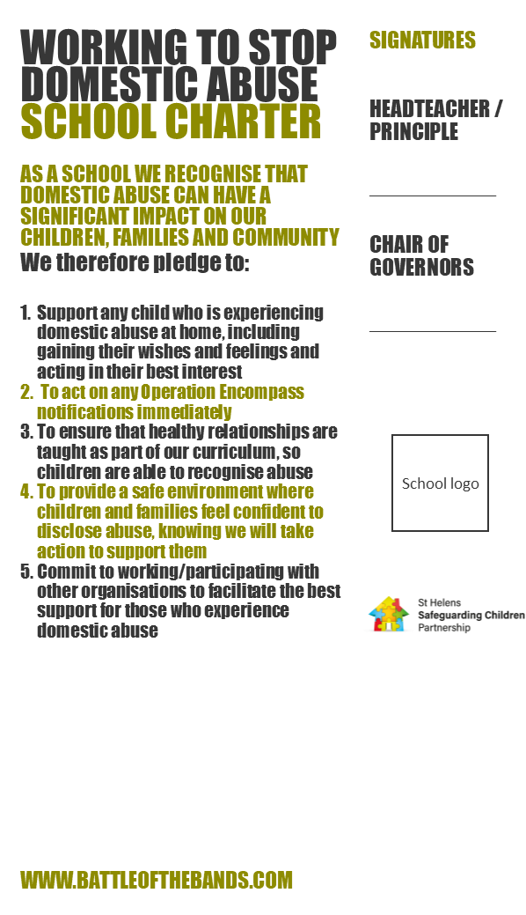

Appendix – STAR Protocol
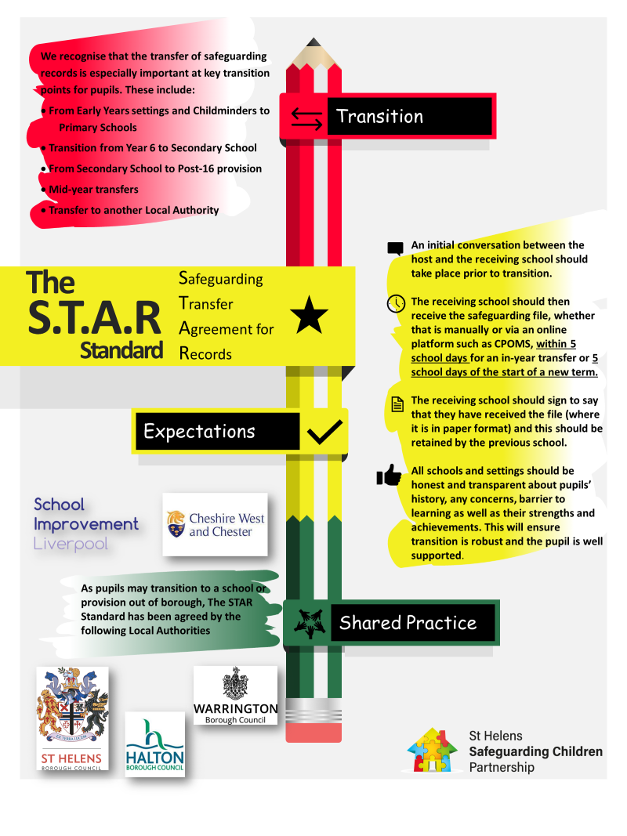
Appendix – St Helens Flowchart
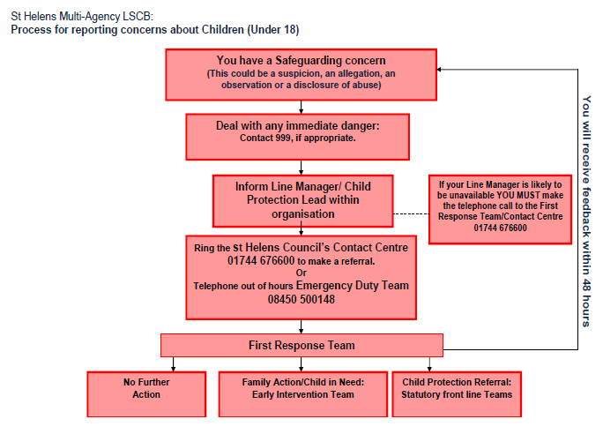

Appendix – Sharing Concern Form (Yellow)
Name of Child / young person: Date of birth and age:
Male/female: | Ethnic Origin: | Disability Y/N: | Religion:
Day & date of concern | Month | Year | Time recorded / reported
Siblings’ names and DOB:

Initial report of the concern / s: In factual terms; what did the child say? How are they feeling? How is their behaviour? Are there any signs of injuries or pain? (If so, illustrate on body map) Are any other children or adults involved? If additional space is needed to record information, please see final page of this form. |  |  |  | Examples of what you might say:  “You have done the right thing by telling me…”  “This is important. I need o speak to Mr Weston about it.”  “I will do my best to help you.”  Questions:  Observe & listen – don’t ask leading questions  Give the child time and space to answer your questions  Do not over-talk or interrupt  Use short, open-ended questions  Productive Questions  Where Tell me In detail  When Explain Exactly  Who Describe  What Show me  How
Additional information: Your views on what you know about the child e.g. Any previous concerns? How are they doing in school? Any comments on their presentation, their personal circumstances (such as health, development and whether they have any additional needs), their identity, race, religion and/or if known, their social relationships with their family, friends and wider networks?

Your response and actions to the concern: What you have done / said to the child or agreed to do?

Your name:
Your role or position:
Your signature:
If not an employee of the school, please ensure you provide your contact details, should the DSL need to contact you regarding your concern.
Headteacher/ DSL’s immediate response and actions taken: Include sharing and gathering information, speaking to child, parents or carers and gauging their response. This may also include undertaking a professional consultation. Has any immediate risk assessment been carried out if so, what?

Information shared with Parents / carers? Are they aware of school’s concerns / actions carried out to support / safeguard CYP? Do you have consent for this? If not rationale for not sharing information?

Information shared with other staff/ agencies? Who, what, how and your rationale for this?

Outcome for the Child: What level of intervention is required to safeguard and promote the CYP welfare? i.e. where does this level of need sit on the Continuum of Need document www.thegrid.org.uk/info/welfare/child_protection/referral/index.shtml#need
- Universal, Targeted, Intensive Support or Specialist/Safeguarding?

Feedback given to member of staff reporting concern: This is to be an overview omitting any confidential information, consider ‘need to know’

Your name:

Your role or position:

Date, day and time of this recording:

Your signature:
Checklist for DSP (to be printed on back of record of concern form)
- Child clearly identified.
- Name, designation and signature of the person completing the record populated?
- Date, day and time of any incidents or when a concern was observed?
- Date, day and time of written record?
- If a third party has raised concerns, are details of this person included (name, relationship to the child and their contact details if relevant)?
- Distinguish between fact, opinion and hearsay
- Concern described in sufficient detail, i.e., no further clarification necessary.
- Child’s own words used. (Swear words, insults, or intimate vocabulary should be written down verbatim)
- Are the names of all parties who were involved in the incident, including any witnesses to an event included? Is it clear what their relationship is to the child?
- Record free of jargon?
- Written in a professional manner without stereotyping or discrimination?
- What did the member of staff say or do in response to the concern?
- Record of concern completed in a timely manner.
- Record of concern passed to DSP in a timely manner.
- The record includes an attached completed body map (if relevant) to show any visible injuries – see attached.
- Is any additional paperwork, e.g., handwritten notes of conversation with parents attached securely to this record?
- Has DSP completed their sections in full- including action taken and outcome, feedback to staff and information sharing?
- If the concerns have not been referred to Children’s Services/Police, are the reasons clearly recorded by the DSP?
- Has this form been added to chronology in CPOMs?
Audit date: |  | Audited completed by:
Overall RAG rating (see key below)
Action needed | Timescale |  | Name and position of person responsible | Date action completed

RED | Indicates that information from the checklist is lacking and deficiencies need to be addressed as a matter of urgency
AMBER | Indicates that key information is included but recording could be further improved
GREEN | Indicates that the recording meets the above required standards

If you intend to give a copy of the above action plan to the member of staff, please ensure they are not given page 1, i.e., the actual record of concern form which contains confidential details.

Oakdene Primary School
BODYMAP
(This must be completed at time of observation)

Name of Pupil: |  |  | Date of Birth:
Name of Staff: |  |  | Job title:
Date and time of observation:

 | 

Name of pupil: |  |  | Date and time of observation:
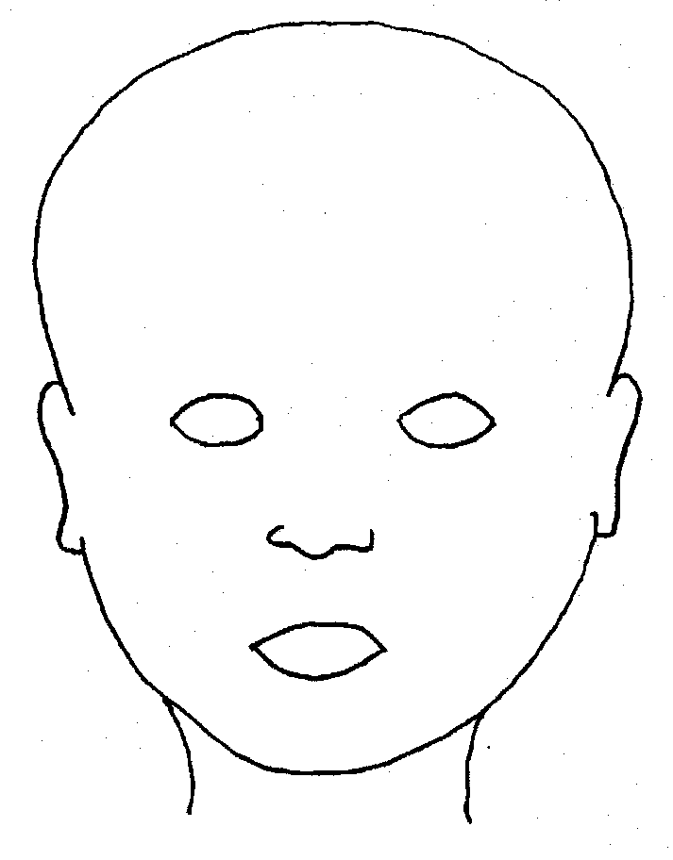 |  | 
FRONT |  | BACK
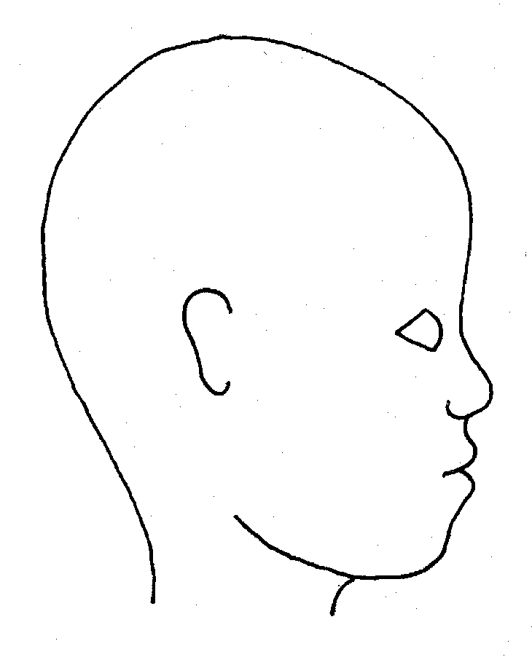 |  | 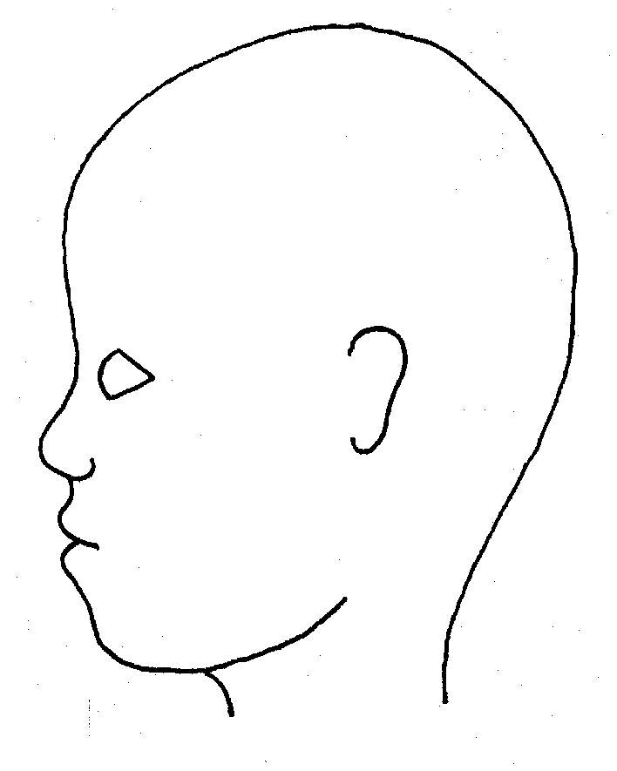
RIGHT |  | LEFT

Name of pupil: |  |  |  |  |  |  | Date and time of observation:
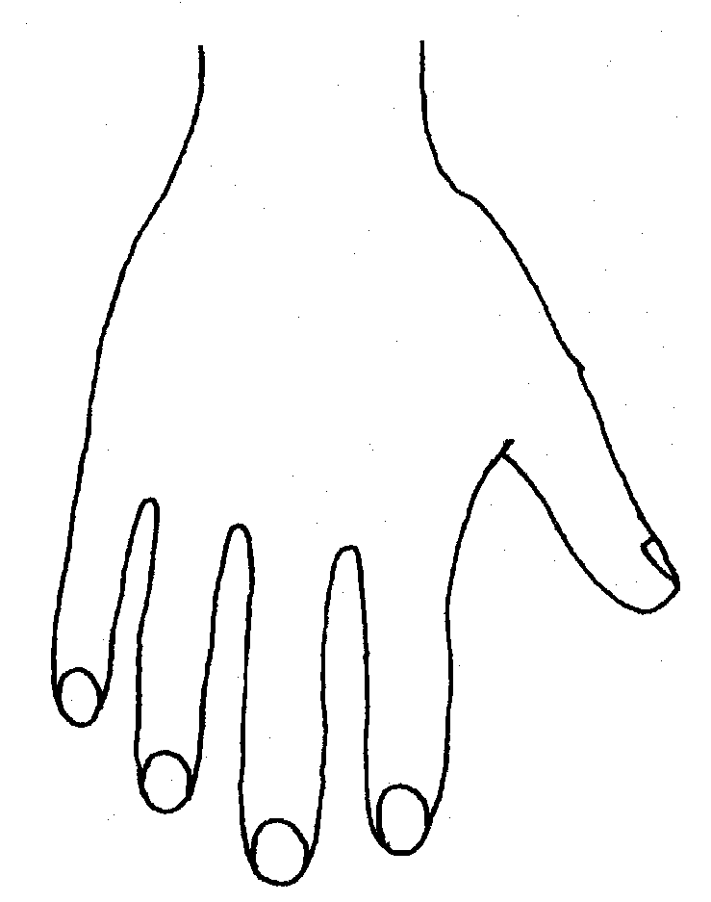 |  |  |  |  |  | 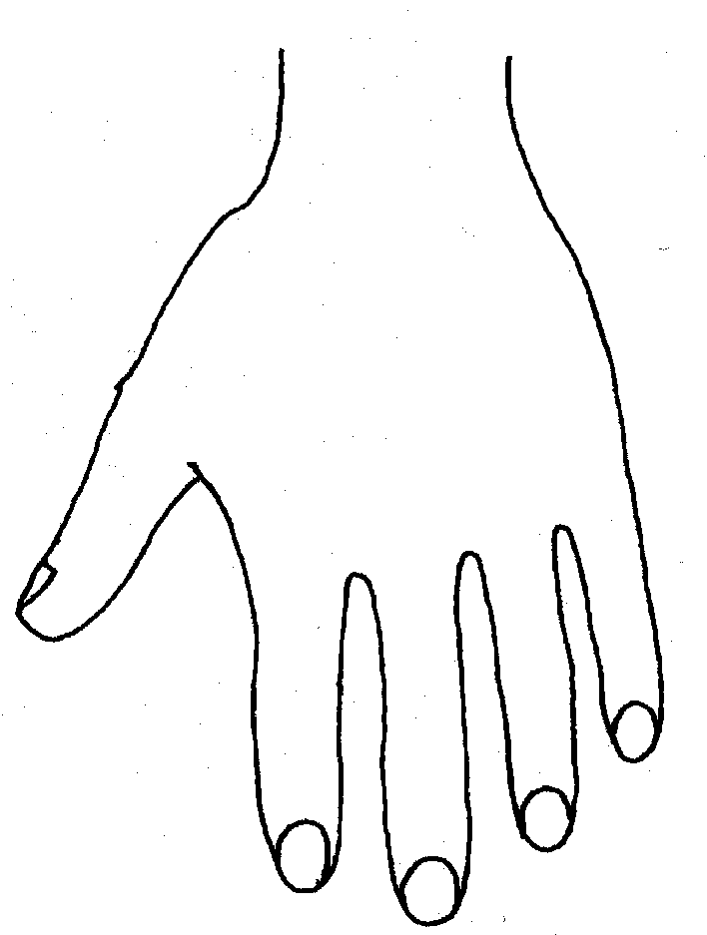
R |  |  |  |  |  | L
BACK

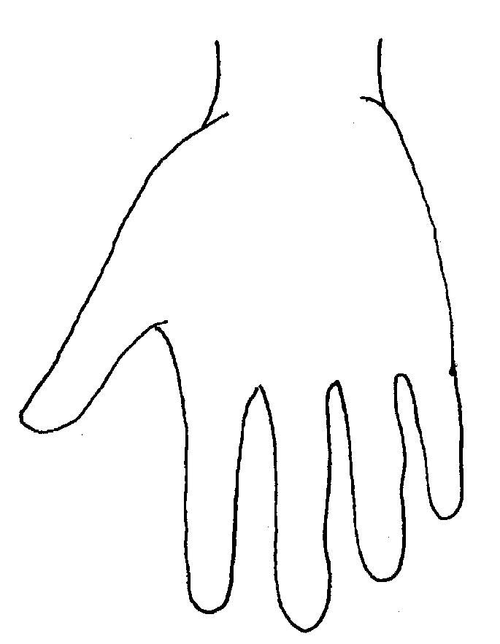 |  |  |  |  |  | 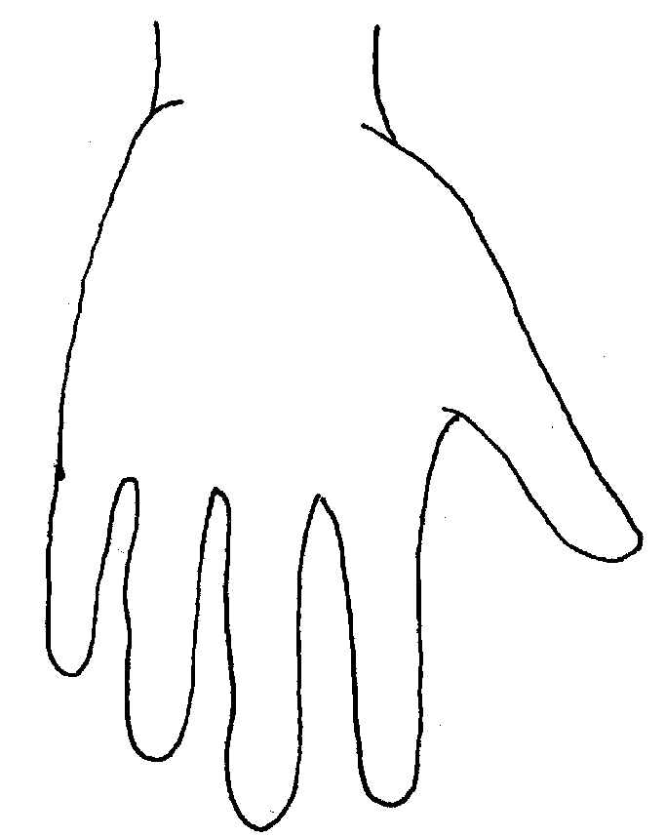
Name of Pupil: |  |  |  |  |  |  | Date and time of observation:
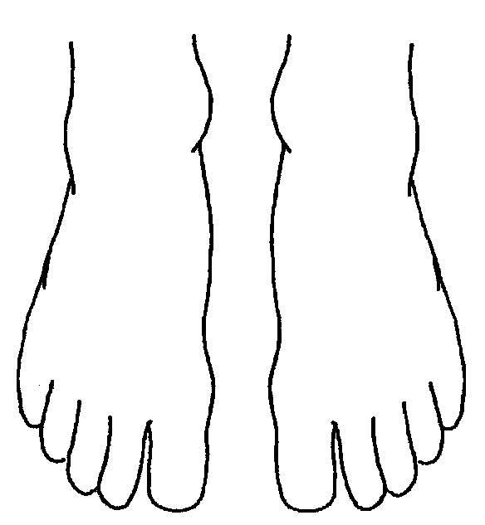 |  |  |  |  | 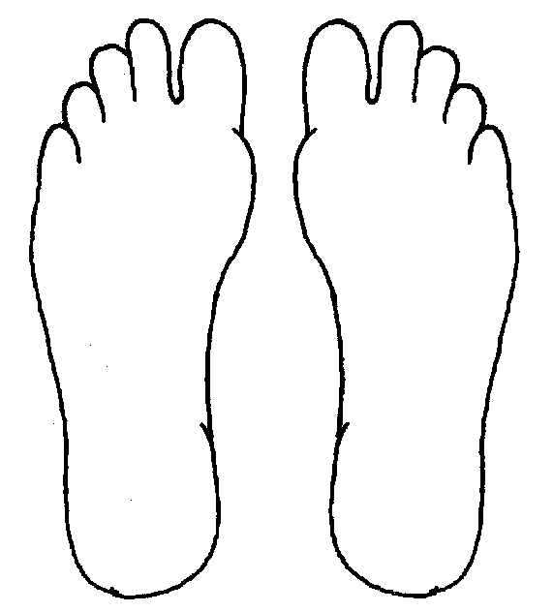
R | TOP |  |  | L | R |  |  | BOTTOM |  |  |  | L
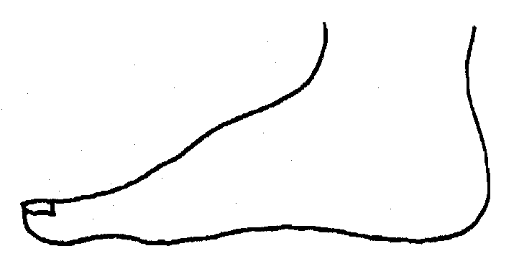 |  |  |  |  | 
R |  |  |  |  | L
INNER
 |  |  |  |  | 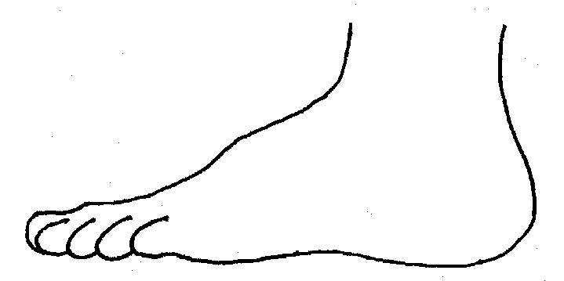
R |  |  |  |  | L
OUTER
Printed Name, Signature and Job title of staff:

Additional notes made:

Appendix – Designated Safeguarding Leads Poster

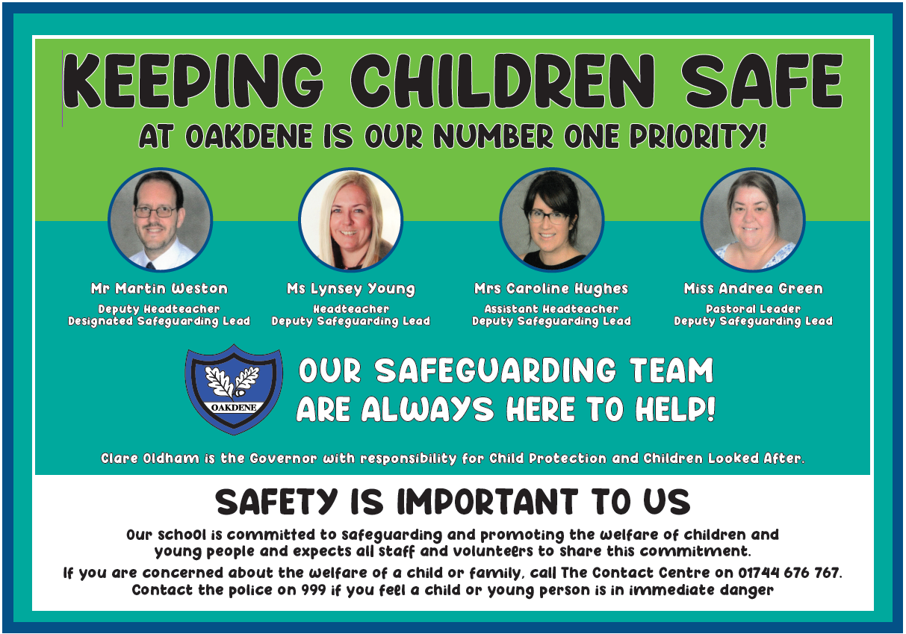

Appendix – Staff Policy Signing Sheet
Oakdene Primary 2024 - 2025
Please sign and return to Martin Weston (DSL)

I, _______________ (name) have read and am familiar with the contents of the following documents and understand my role and responsibilities as set out in these document(s).:

(1) Oakdene’s Child Protection & Safeguarding Policy
(2) Part One OR Annex A and Annex B of 'Keeping Children Safe in Education' DfE Guidance, 2024
(3) Oakdene’s Staff Handbook
(4) Oakdene’s Code of Conduct
(5) Oakdene’s E-Safety Policy inc Social Media Policy
(6) Oakdene’s First Aid Policy
(7) Oakdene’s Medical Conditions Policy
(8) Oakdene’s Behaviour Policy
(9) Oakdene’s Anti-Bullying Policy
(10) Oakdene’s Attendance Policy & Procedures
(11) Oakdene’s Whistleblowing Policy
(12) Oakdene’s Sharing Concern Form

I am aware that the DSLs/DDSLs are:
…………………………………………………………………………………………………………………………………………………………………………………………………………………………………………………………………………………………………………………………………………………………………………………………………………………………………………………………………………………………………………………………………………………….
and I am able to discuss any concerns that I may have with them.

I know that further guidance, together with copies of the policies mentioned above, are available on staff share, on the school website and accessible through the school office.

Signed_____________________________________________ Date___________________

